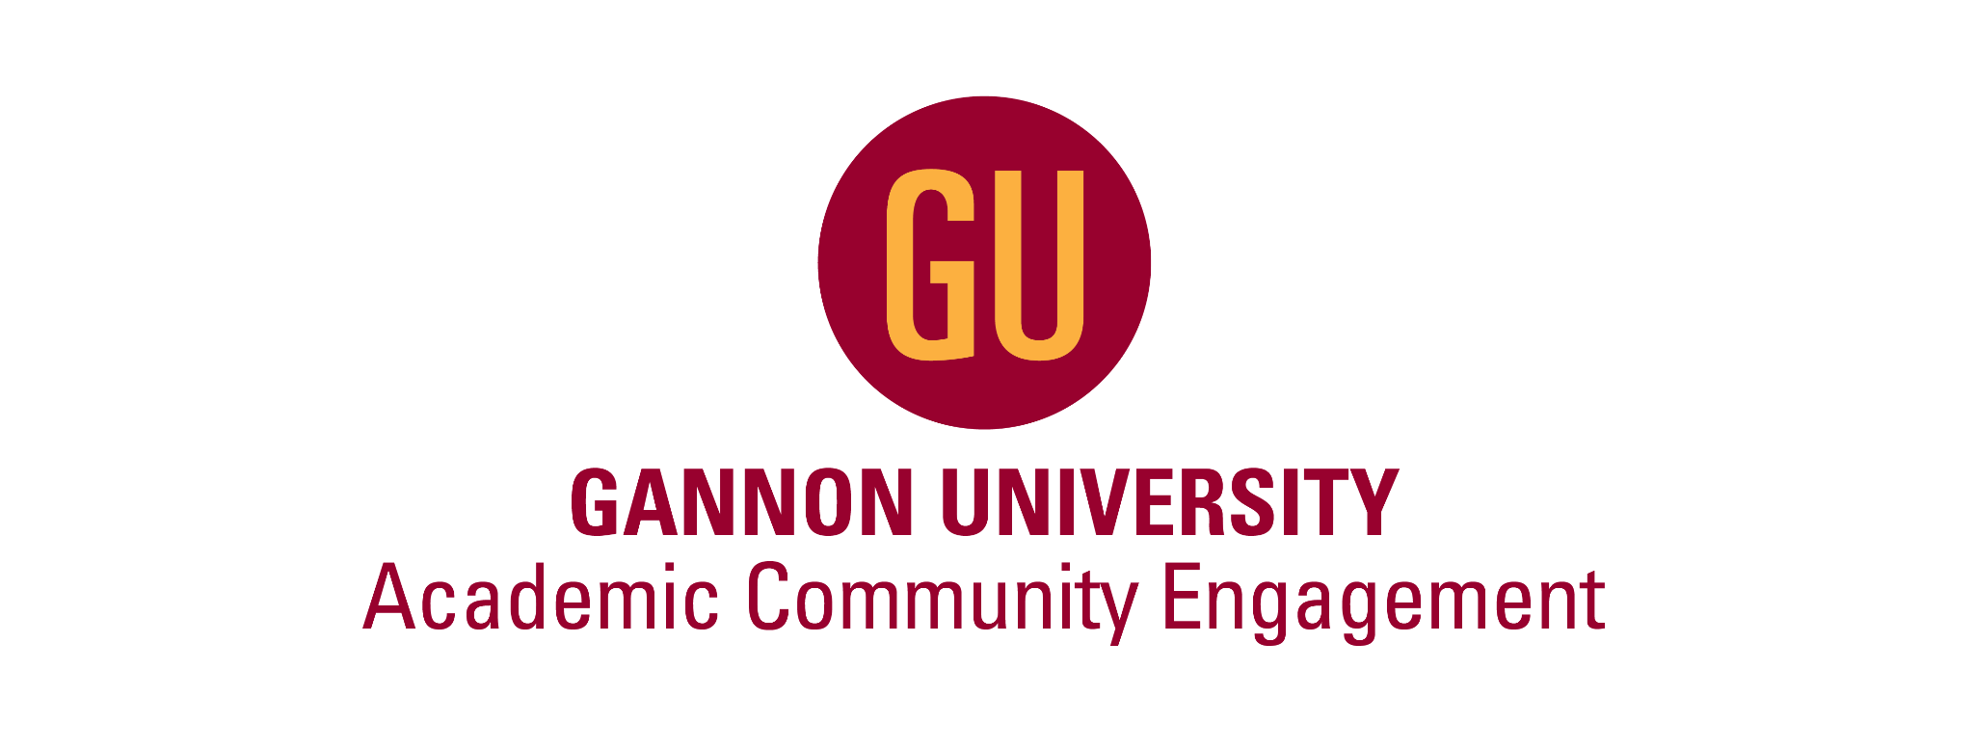
“Beyond the Classroom” Conference Marketing Plan
Gannon University
AK Public Relations
Ash Keenan
January 24th, 2023

Table of Contents
- Introduction 3
  - Staff Bios 4
- Situation Analysis 8
- SWOT Analysis 23
- Research Summary 24
- Target Market/Audience 28
- Objectives and Goals 33
- Big Idea 34
- Marketing Communication Strategies 35
- Budget 78
- Timetable 80
- Conclusion 82
- Sources 83

- Introduction
The office of Academic Community Engagement (ACE) is an academic organization centered around service-learning at Gannon University. According to their page on EngageU, “Service learning is a credit-bearing, educational experience in which students participate in an organized service activity that meets identified community needs and reflect on the service of activity in such ways as to gain further understanding of course content, a broader appreciation of discipline, and an enhanced sense of civic responsibility.”
In 2022, the first ever regional service-learning conference occurred. The conference is titled “Beyond the Classroom: Community-Engaged Teaching and Research”. The purpose of this conference is to connect community-engaged practitioners from various colleges and universities to share and learn best practices from shared experiences. The conference gives attendees a chance to deepen their knowledge and skills surrounding community-engaged teaching and research and connect with many colleagues in the realms of higher education. This plan will provide an organized layout of the marketing pieces needed to promote this event to produce desired results for ACE in alignment with their established objectives.

- Staff Biographies:
Daniel Salamone, Director

Daniel Salamone is the current Director of the Office of Academic Community Engagement (ACE) Honors Program. He graduated from Marist College with a Bachelor of Arts degree in Political Science and Government. Daniel continued his education at Mercy College to receive his Master’s degree in Organizational Leadership. Learning for Mr. Salamone did not stop there as he is currently enrolled in the PhD program at Gannon University in Organizational Learning and Leadership.
Throughout his time of education, Daniel has held many professional positions. Some of his notable positions include academic advisor, managing director, and adjunct professor. Daniel has been with ACE for some time now, first being hired as the Assistant Director in January of 2020 and promoted to Director in July of 2022. He currently oversees all operations of both the ACE and Honors program as well as provides resources and information on service-learning to university faculty.
Sabrina Kauffman, Program Assistant

Sabrina Kauffman is the Program Assistant for Honors and the Office of Academic Community Engagement. She graduated from Gannon in 2019 with a bachelor’s degree in English literature. After graduation, Sabrina moved to Japan to teach English as a foreign language for a year while immersing herself into Japanese culture. Due to the pandemic, Sabrina moved back to the states where she took up teaching Special Education in Cary, North Carolina. While in North Carolina, Sabrina enrolled in a Master of Arts program in English literature.
After moving to Erie for the second time in her life, she decided to apply to Gannon University to gain experience in higher education. After graduating with her MA in the summer of 2022, she quickly decided that teaching English and writing was her passion. Sabrina is currently looking at PhD programs throughout the United States and is hoping to become the Elle Woods of the literature field.
Currently at Gannon, Sabrina is active in many departments and has built many wonderful relationships while working there. Sabrina likes long hikes with her dogs Anchovy and Bronte. She also loves late night food runs and driving while listening to true crime podcasts.

- Situation Analysis
A situation analysis is defined as an analysis of the internal and external factors of an organization or business. It clearly identifies an organization's capabilities, customers, potential customers, and their impact on the company. A situation analysis is an essential part of any plan and should be reviewed periodically to ensure that it is current. When conducting a situation analysis, the key focuses are a company analysis, product analysis, competitive analysis, consumer analysis, and market analysis.

- Company Analysis:
The office of Academic Community Engagement (ACE) at Gannon university is an organization focused on implementing service learning activities for both faculty and students. The organization was created in spring of 2021, being modeled after The Office of Service and Learning. The office worked with organizations in many fields such as afterschool programs, animal welfare, arts and culture, criminal justice, disaster relief, economic development, environmental sustainability, food security, health and wellness, homelessness, neighborhood development, peace and justice, persons with disabilities, refugee resettlement, and senior citizens. However, the office was shut down in 2015 due to budget cuts. Hence, ACE was created to restructure service learning to be used again in the universities’ curriculum. What went from a notably sized office now consists of only two full-time staff members and four student workers. The organization operates out of Gannon University in Erie, Pennsylvania within the Palumbo Academic Building on the first floor.
ACE carries out their purpose through its services provided at Gannon. The primary function of ACE is to work with all service learning practices that professors will pursue in higher education. In addition, the office helps to guide faculty to teach lessons with community outreach. Another function of the office is to create courses and design projects that integrate aspects of community outreach. Subsequently, ACE provides support for faculty that want to engage in research. The office helps to create research opportunities in which discoveries can be published to promote community research. ACE supports students as well through publications that can lead to national scholarships and fellowships. The most recent service that ACE provides is the “Beyond the Classroom” service learning conference. The conference invites faculty and staff from across the tri-state area to submit proposals on their community outreach and service learning in the classroom. Once proposals are selected, individuals will be asked to present their topic at the conference to other like-minded individuals.

- Product Analysis:
General Services:
ACE currently provides a variety of services to faculty, staff, and students at Gannon University and also within the tri-state area of Erie County, Pennsylvania. ACE primarily functions as a resource for faculty and staff to refer to when pursuing service learning practices to utilize in their higher education curriculum. They help guide both groups to teach lessons that involve community outreach rather than being confined to the walls of the classroom and the bounds of a lesson plan. Some ways that they help to guide faculty and staff includes creating courses and designing projects that constitute that of community outreach. Additionally, ACE provides research opportunities for professors that are interested in publicating research that can lead to further community research. As for students, ACE helps lead them to national scholarships and fellowships through their personal educational publications.
“Beyond the Classroom” Conference:
ABOUT
The most recently developed service through ACE is the “Beyond the Classroom” conference. “Beyond the Classroom '' was first held in June of 2022 in Waldron Campus Center room 219 at Gannon University in Erie, Pennsylvania. This is a conference centralized around the idea of service learning and community engagement and outreach. Service learning can be defined as, “a credit-bearing, educational experience in which students participate in an organized service activity that meets identified community needs and reflect on the service activity in such a way as to gain further understanding of course content, a broader appreciation of the discipline, and and an enhanced sense of civic responsibility.” (Gannon University). Service-Learning builds innovative bridges among students, faculty and community agencies, enriching courses to be socially relevant, beneficial to the community, and supportive of excellence in teaching and learning. The purpose of this conference is to connect community-engaged practitioners from various colleges and universities to share and learn best practices from shared experiences. The conference gives faculty, staff, and even students the chance to deepen their knowledge and skills surrounding community-engaged teaching and research and connect with many colleagues within the realms of higher education. However, it is mainly meant for faculty who want to integrate this into their teaching strategy.
HOW IT WORKS
Before the conference, those that sign up will be instructed to complete a survey via the Eventzilla website. This survey will be used to predetermine a schedule for what particular breakout sessions each person will be attending. Attendees will receive their schedule in advance, but can switch a session last minute if needed. The conference will have various rounds with 3-4 different sessions per round. The first couple rounds will be centered around service learning presentations that various faculty, staff, community partners, and even students submitted via a proposal. Proposals are accepted on various service learning topics from December to February via the Eventzilla website. Topics will be determined and announced to the target audience sometime in February. The next round involves attendees visiting local community partners to experience service learning resources firsthand. The rounds are concluded with a panel and keynote speaker. This will also be announced in February. All together, there are expected to be around 17 designated speakers at the conference. After all rounds conclude, attendees are invited to a mixer at Molly Branigan’s Irish Pub. This mixer invites attendees to further dive into the topics they learned about earlier that day with their peers and potentially the speakers. Furthermore, the mixer encourages networking and connections to be made amongst those that attend.
THIS YEAR
The conference will be held this year on Friday, June 2nd, 2023. At a financially affordable cost of $50, attendees receive not only admission, but also breakfast, lunch, and tickets for a mixer. In addition to ACE, a cosponsor includes the group Partners for Campus Community Outreach. Their resources are used to help promote conferences on multiple facets. The conference will be prompted and managed through a third-party website titled Eventzilla. This website includes all important information about the event, images, documents, and provides a source of communication to participants. Eventzilla will also be the method in which RSVP’s and payment for the event are taken as well.
Some changes this year will be made in order to improve the overall productivity of the event. A cocktail meet and greet party will be held the night before on Thursday, June 1st. This gives attendees the option to arrive a day beforehand and get settled if they are traveling from a greater distance. Another change this year is that attendees will know beforehand what presentations they will be attending. This will be determined through a survey that will be administered via the event site, in which individuals will rank which topics pique their interest the most. This will help to gauge how large of a room is needed for the various presentations based on the size of the audience. However, if needed, guests may change which session they would like to attend last minute.
SCHEDULE
A general schedule for the conference this year is as follows:
- 9:00 - 9:45 a.m. Registration & Light Breakfast
- 9:45 - 10:00 a.m. Welcome and Introductions
- 10:00 - 10:50 a.m. Breakout Sessions Round 1
- 10:50 - 11:10 a.m. Transition Break
- 11:10 - 12:00 p.m. Community Partner Site Visits
- 12:00 - 12:20 p.m. Transition Break
- 12:20 - 1:30 p.m. Lunch & Learn Keynote Speaker
- 1:30 - 1:40 p.m. Transition Break
- 1:40 - 2:30 p.m. Breakout Sessions Round 2
- 2:30 - 3:30 p.m. Panel Discussion
- 4:00 - 6:00 p.m. Mix & Mingle

- Competitive Analysis:
Campus Compact
Campus Compact is a national service-learning non-profit organization committed to advancing the public purposes of higher education. The group was founded in 1985 by presidents at respective colleges Brown, Stanford, and Georgetown. These higher educational leaders shared a concern for the strength of democracy. They felt that education could be a more effective contributor to the sustainability of democracy with more robust structures for community engagement. Therefore, its headquarters were established in Boston, Massachusetts, becoming a support system for institutions by helping them build the knowledge, skills, and capacity needed to enable a just, equitable and sustainable future. It is now the largest and oldest association dedicated to higher education’s civic and community engagement. Community support for them is strong, with members including thousands of presidents, faculty, researchers, students and civic and community engagement experts at colleges and universities. This strong sense of developed communal support has allowed for the non-profit to work with hundreds of campuses directly through state and regional affiliates across the country to support them in their community’s engagement work, connect community engaged scholars and practitioners, and continue to move the field of higher education and civic community engagement forward. In fact, ACE is modeled after this organization.
Vision:
“Campus Compact advances the public purposes of colleges and universities by deepening their ability to improve community life and to educate students for civic and social responsibility. Campus Compact envisions colleges and universities as vital agents and architects of a diverse democracy, committed to educating students for responsible citizenship in ways that both deepen their education and improve the quality of community life. We challenge all of higher education to make civic and community engagement an institutional priority.”
Values:
- Equity- Full participation, diversity of thought, experience, and background are prioritized. Equity is the center of actions, processes, and practices to uplift diverse voices and perspectives.
- Growth mindset- Ourselves and others are consistently pushed to do and be better. Growth is a motivator, embracing new ideas, prioritizing continuous learning, and meeting challenges head-on.
- Accountability- It is recognized that long-term change requires individual and shared ownership of personal and organizational actions. Campus Compact owns their mistakes, gives each other grace, collaborates openly, and holds themselves to high standards of integrity.
- Responsiveness- Offerings, resources, and approaches are ensured to be flexible, grounded with feedback, and responsiveness to the challenges of our time.
- Transparency- Campus Compact is direct with their team, members, and partners. They are aware that building trust starts with consistent, honest, and transparent communication.
In 2016, the organization started offering a national conference to convene senior leaders, faculty, staff, and students for learning and sharing about their work pursuing the public purposes of higher education. Sessions at the conference explore topics such as civic engagement, community engaged research, civic and service learning, institutional change, and university/community partnerships. The duration of the conference is typically three days long in early to mid spring. Conferences however for the past few years have been held virtually due to the pandemic. The last in person conference was in 2018 in Indianapolis, Indiana. In addition to national conferences, the non-profit offers a multitude of other programs to its members. These programs include Communities of Practice, Community College Network, Dialogue and Deliberation, Engaged Scholars Initiative, Faculty Development, HUD + Higher Education Engagement Network, Innovation and Design Initiatives, National Conferences, Opportunities to Lead, Pathways of Public Service and Civil Engagement, Resourcing for Success, TRUCEN, and Affinity Networks
Campus Compact’s website is etched with marketing resources throughout. Their website offers a “subscribe” option, in which individuals can sign up to be on an email list to keep them up to date on conference information all year long. Additionally, their website offers access to recordings and videos from past conferences. Their social media is not directly linked on their website. However, the association does have an active Facebook with 3.1K likes. Their website also includes a media section that comprises their past media coverage. A FAQ section is also included to provide further information to their audience, an effective marketing tactic.

- Consumer Analysis:
The consumers of ACE’s services are faculty, staff, and students who attend or work for colleges and universities in the tri-state area. Being only the first year for the event, the conference produced a decent outcome of 60 attendees. Out of those that attended, 26/60 were faculty, 1/60 was a community partner, 22/60 were staff members, and 10/60 were students. As reflected through the numbers, attendees mainly consisted of faculty, followed by non-teaching staff, then students and community partners. The institutions that these attendees came from include Allegheny College, Medaille College, Mercyhurst University, Niagara University, Slippery Rock University, University of Mount Union, Buffalo State College, Duquesne University, La Roche University, Northern PA Regional College, Penn State Behrend, St. Vincent College, and majority from Gannon University. The target consumers for the Beyond the Classroom conference are teaching faculty at higher education colleges and universities. According to Zippa.com, as of September 2022 there are currently 135,097 professors employed in the U.S. The Beyond the Classroom conference serves faculty across all departments within any higher educational setting.
Majority of the faculty will be a part of the baby boomer generation. This generation shares the value of redefinement. They are open minded to change and are particularly interested in restructuring that outputs positive results. This is beneficial for the conference, as it promotes changes in the structure of teaching curriculum. Baby boomers are also financially stable, leaving them to have a larger amount of disposable income to use on leisure and extracurricular activities. Another notable psychographic of this group is their technological skills. Though not digital natives like those born within Generation Z, this group has caught up to speed, deeming themselves as technologically savvy. Having access and interest to a resource like the internet prompts them to further integrate it into their daily lives.

- Market Analysis:
In comparison to the market, ACE is flourishing due to the market not being that heavily saturated with service learning conferences, especially in the Erie tri-state area. Essentially, ACE supplementing what the market is lacking currently. Consumers are able to receive information the same caliber as a national conference, but at a much more affordable price. It is the cheapest available conference in the market, making it one of ACE’s strengths and even a unique value proposition. From the opportunity for a great learning experience at an affordable cost at the conference, to having access to an endless amount of educational resources with ACE, consumers will associate a positive and innovative growing experience in recognition with ACE. This idea of growth and innovation will serve as an advantage to consumers who are interested in community engagement and service-learning based teaching.
When looking at the market, there are 227 colleges and universities within driving proximity of Gannon, residing in the states Pennsylvania, New York, and Ohio. Almost every school in the market utilizes service learning and has it readily available to some degree. Service learning though active at various institutions may not be the most prominent organization on campus due to lack of education and resources. As a response, organizations such as ACE and Campus Compact were created to help these schools improve. Though within the same market, Campus Compact acts as a foundation for ACE since it was modeled after it. The overarching goal of these organizations is providing opportunities and resources for education in service-learning based teaching and community engagement, having it become more prevalent in teaching curriculum. This will make this type of education more meaningful and effective to create positive change for students and the community. Although similar, these two groups have different primary initiatives. ACE is primarily focused on sharing educational experiences whereas Campus Compact is focused on intervention and providing solutions. These associations typically target a demographic group of higher education teaching faculty with their services.
With education serving as an integral asset to the U.S., service-learning organizations and the unique services they provide will continue to grow in the process. Since colleges and universities can only provide so much initial education, having additional services available will continue to benefit the overall education of students in the area with the increase of service-learning based teaching in classrooms across the tri-state. Pairing together this common trend, the continually growing market, and the financial stability of consumers will set up a wide open market to capitalize.

- SWOT Analysis
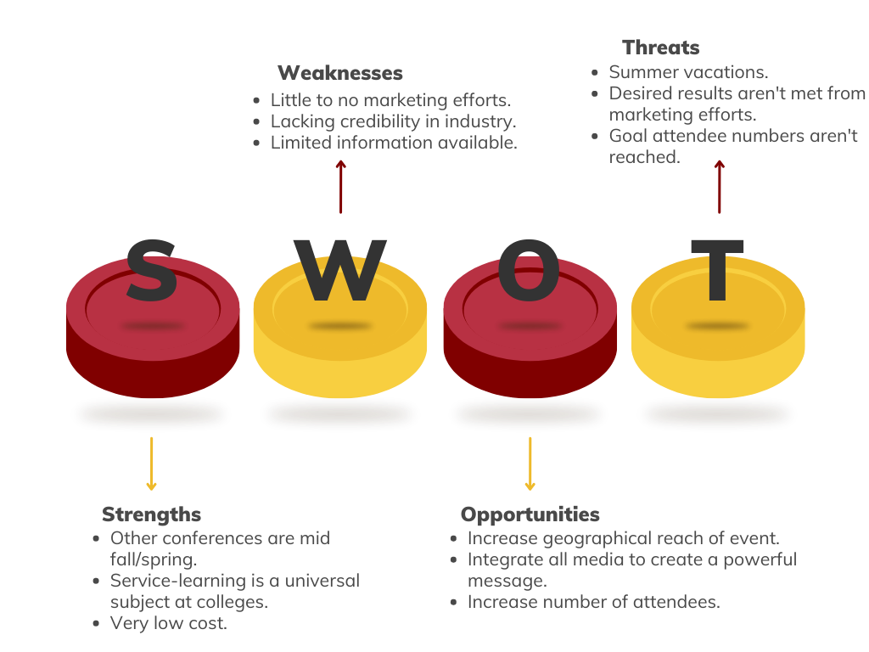

- Research Summary
- Primary = surveys
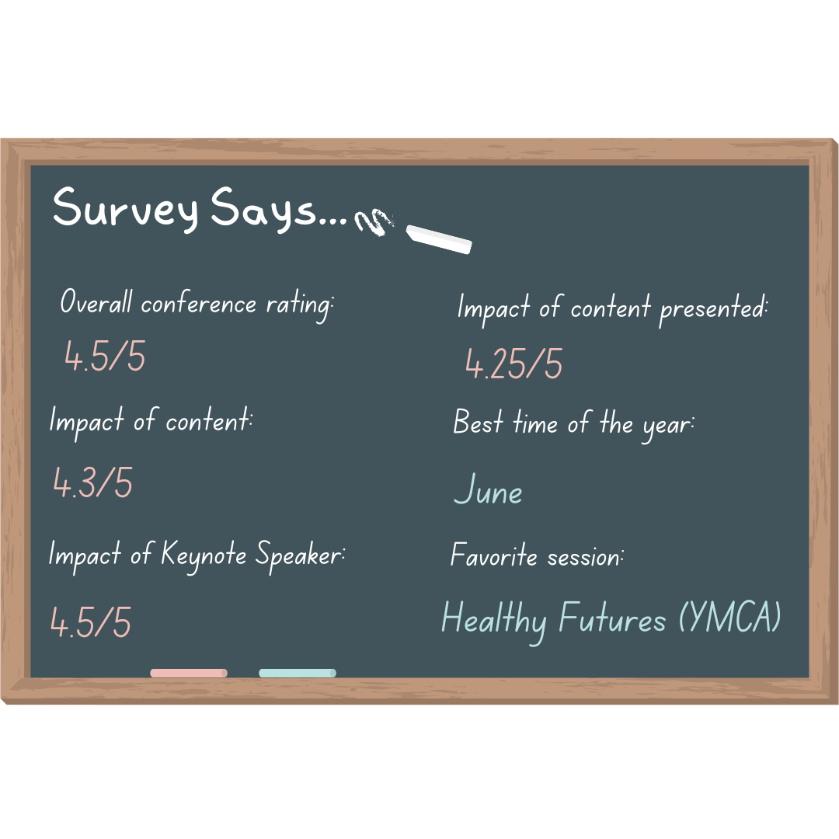

- Secondary = online
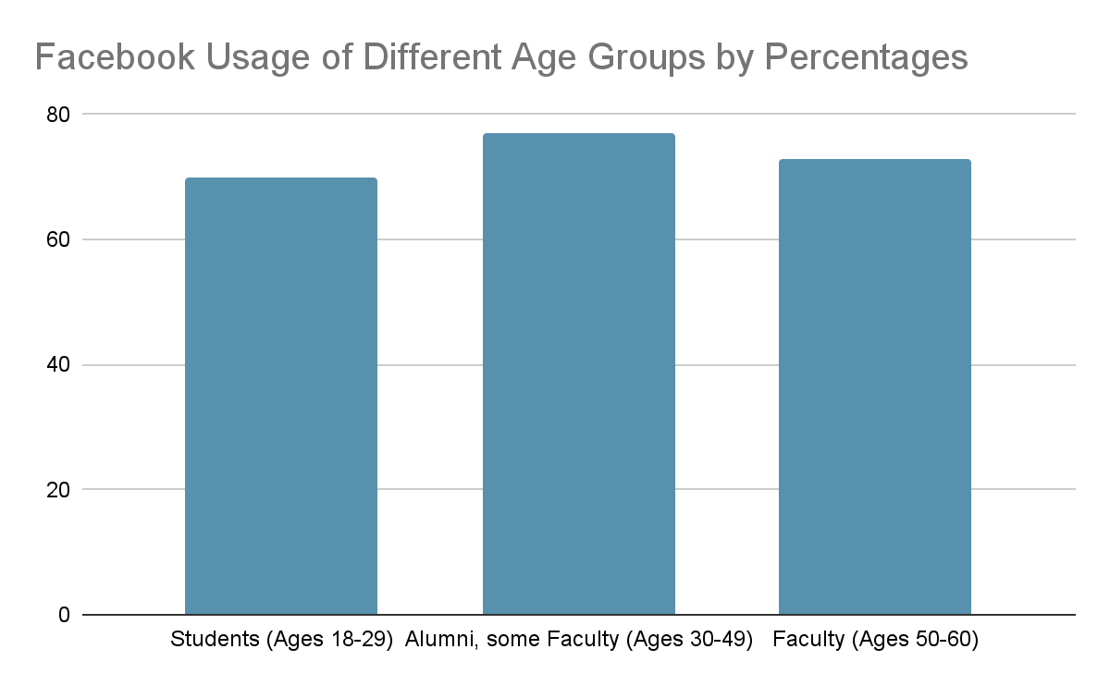Data derived from: https://blog.campussonar.com/blog/social-media-demographics-for-higher-ed-2021

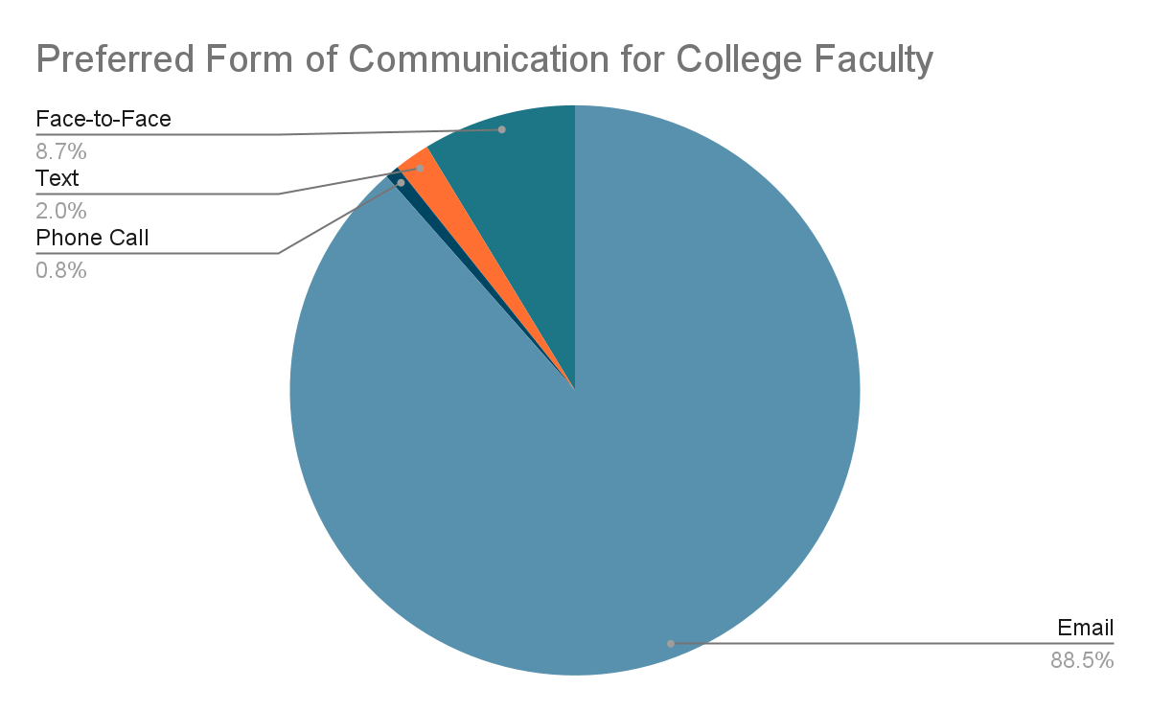

Data derived from https://www.ncbi.nlm.nih.gov/pmc/articles/PMC8887060/

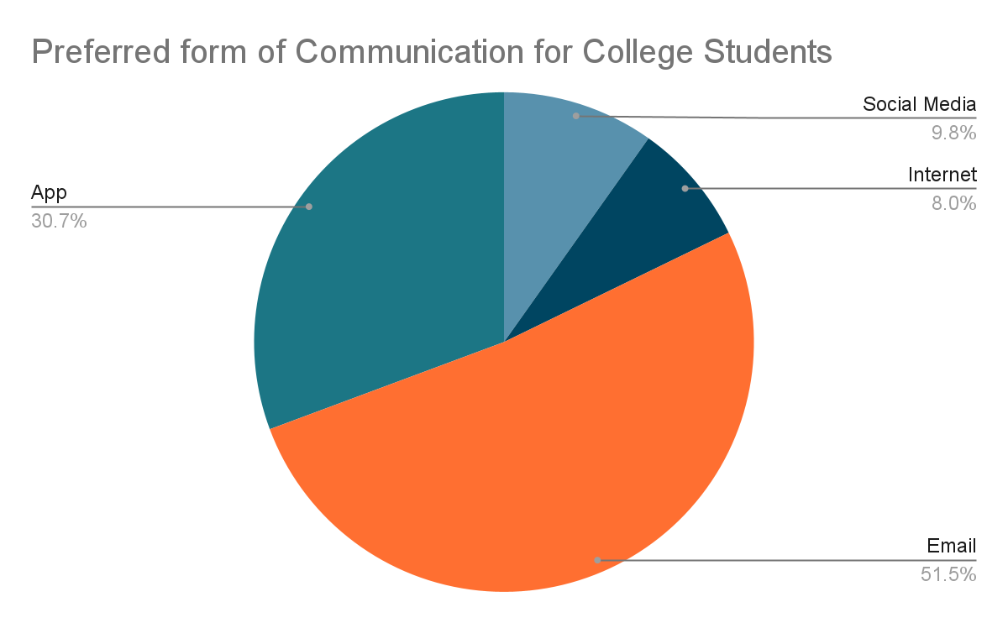
Data retrieved from: https://stucomm.com/blog/preferred-student-communication-channels/

- Target Audience
Based on both primary and secondary research conducted, three main target audiences have been identified to better focus marketing communication efforts in sequence with the established objectives. The markets being targeted geographically all remain within driving proximity of Gannon University. These geographical regions include those within and surrounding: Erie, PA; Meadville, PA; Jamestown, NY; and Ashtabula, Ohio. The three target audiences include college faculty, staff, and students.
Primary Target Audience
The identified primary target audience for this marketing plan is college faculty. Faculty includes people who teach in a university within one of its departments. They have been identified as the primary audience as they are the main group to attend the conference and also have an interest in teaching in relation to service-learning. Members of this group geographically reside within the tri-state area of Gannon University, and are employed at one out of 227 accredited universities. A list of the accredited universities can be seen HERE. Once this group attends, they can be utilized as a tool in word-of-mouth marketing to convince their colleagues to attend the following year. According to Zippa.com, there are currently 135,097 professors employed in the U.S. The gender ratio of this audience is extremely close, with females at 49.8% and males 50.2%. As for ethnicity, the most common is White at 69.4%, followed by Asian at 10%, and Hispanic at 9.8%.
The statistics on this site continue to unveil the average age of this target audience is 45, deeming them a part of the “baby boomer” generation. This generation makes up the majority of the U.S. population, and has the greatest impact in comparison to any other generation on the economy. The baby boomer generation is highly associated with ideas of “rejection” and “redefinement” when it comes to values of tradition. This shared value within this group will be helpful to ACE as they will be more open to new and innovative ideas, such as the ones being presented at the conference. This makes them an applicable group to market as this characteristic can help increase their chances of attendance as the refreshing aspect of the conference aligns with their underlying values. This generation is typically the wealthiest, and have the most disposable income to use on leisurely activities. Though not being born in the generation of technology, baby boomers have caught on quickly, leading them to consume high amounts of television and internet. In fact, ¾ are using social media, 6/10 are reading online blog posts, and 7/10 watch online videos. (GBA.com) It is key to create content for this group that is timely, relevant, and interesting.

Secondary Target Audience
The first identified secondary target audience is college staff. College staff consists of officers and employees within a department, conducting courses for or performing administrative duties at the college. They are an identified target audience for ACE because not only does this group attend the conference, but also could use the information to contribute to developing future curriculum within their respective departments. These individuals also have some sphere of influence over the primary target audience, and can relay information about the conference to the entire department. A study conducted via The Chronicle outlines specific ethnic demographics as well as age demographics about this group, depicted in the graphs below. The graphs are divided into 4-year public universities and 4-year private universities. Based on these numbers, White seems to be the most prominent in this group, followed by Black Americans and Hispanic Americans. As for gender ratio, both public and private see a heavier amount of female staff members.
- 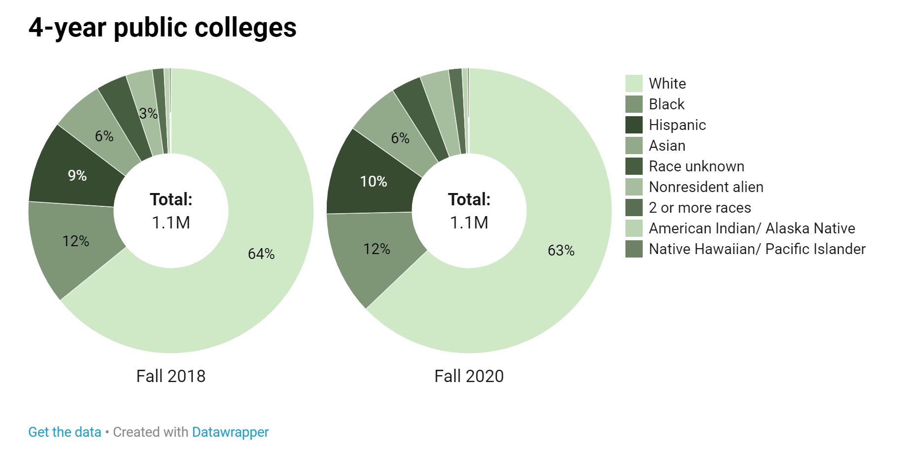
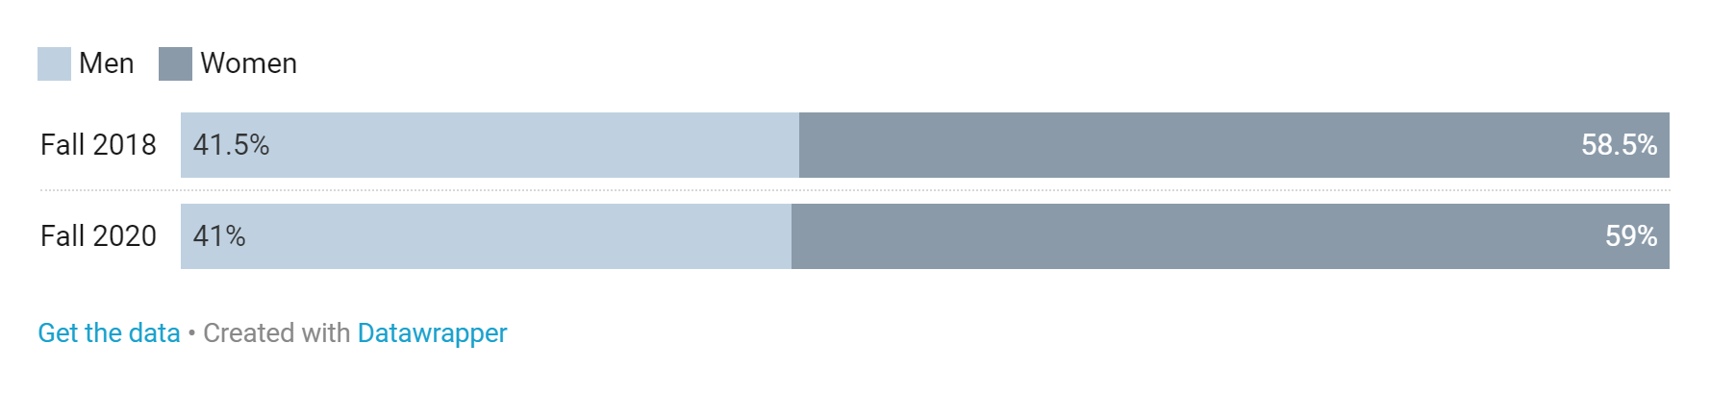
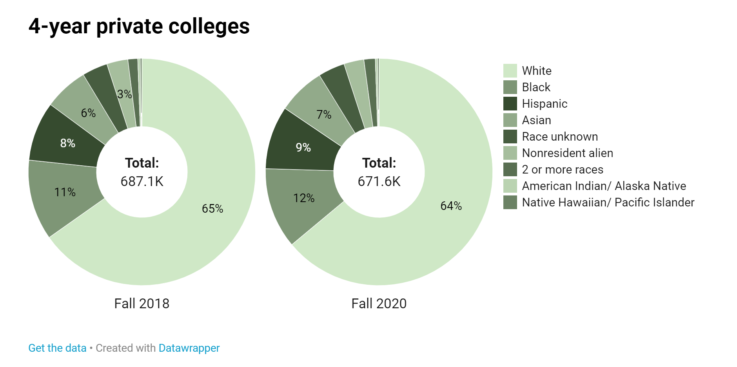
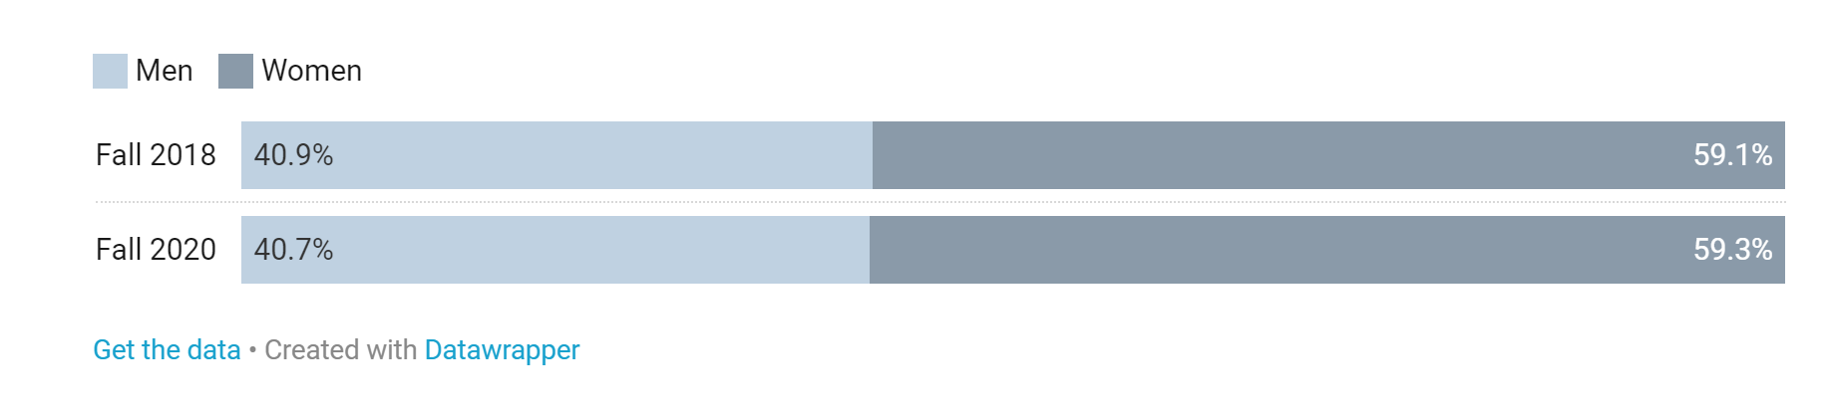

Secondary Target Audience
The next identified secondary target audience for ACE are college students. They are another secondary target audience as they are the other demographic group to make up the attendees at the conference. As of 2020, the ethnicity for this group is one of the most diverse, with statistics reflecting 52% are white, 25% are Hispanic, 14% are Black, and 4% are Asian.
The average age of this group is 18 to 24 years old, falling into Generation Z. NCES.gov outlines a few notable psychographics about this generation, such as the term “digital natives”. This refers to this group as one that was born into the world at the peak of technological advancement and innovation, making the internet easily accessible and social media high in value. Additionally, 90% of Gen Z’s believe that the best education comes from real-life experiences. This is helpful to ACE because service-learning is based around real and hands- on experiences, which may peak the interest of the generation in comparison to others.

- Goals and Objectives
At AK Public Relations, I strive to provide high-quality creative solutions to my clients' marketing efforts. To stay true to this a list of goals and objectives have been created to follow for the proposed marketing communication strategies. The rationale behind setting goals and objectives is to hold accountability while using effective traditional and modern marketing strategies to accomplish our proposed marketing strategies.
- To promote the event to the identified target audience to surge attendance from 60 to 120 by increasing marketing efforts.
- To establish brand awareness of the “Beyond the classroom” conference on a larger geographical scale by implementing strategic direct marketing efforts.
- To grab the attention of the target audience on communication pieces greater than before by designing compelling, minimalistic, and eye-catching marketing pieces.
- To generate more readily available information online by 25% by creating digital presence through social media.

- Big Idea “Beyond the Classroom”
The big idea is a concept that builds on the promotional strategy by joining the service benefits with the consumer in a way that brings the subject to life, in hopes of gaining their attention.The big idea has been determined through not only wanting to achieve IMC, but through analyzing the client (ACE), the services it provides, its competitors, and target audience. Additionally, the organization's strengths and weaknesses have been identified through a SWOT analysis, determining the appropriate marketing communication strategies moving forward.
The proposed big idea is “Beyond the classroom” with a slogan of “Teaching service with public purpose”. Utilizing the name for the event as the central theme will allow for integration to occur. Integrated marketing communications, or IMC, is the coordination of all marketing communication tools into a seamless program involving general advertising, direct marketing, sales promotion, personal selling, and public relations. It recognizes the added value of a comprehensive plan and combines the promotional mix elements to provide clarity, consistency, and maximum communication impact on consumers. Using one cohesive message to communicate to various audiences across all promotional channels produces synergy, eliminates confusion in the mind of consumers, and positions the minds of consumers in a desired way towards the marketer.
The name “Beyond the classroom” communicates how real-life experiences can lead to learning far beyond the bounds of a chalkboard. Service-learning is rooted in a sound understanding of education itself, taking its cue from how cognition and learning actually occur. Service-learning embodies the belief that knowledge is not merely transmitted from teacher to learner, but rather is gained by the learner through guided interaction with the environment.
This recurrent theme promotes this idea that students can grow educationally and as individuals with community engaged learning. It also communicates the many benefits that service-learning based teaching brings to both target audiences. Service-learning supports faculty research and service interests through faculty participation with their communities. Increased student and faculty participation in their communities strengthens the relationship between academic institutions and their communities. Additionally, Service-learning provides students with opportunities to develop civic engagement skills. By working with community members, students can enhance their group, organizational and interpersonal skills. They also can gain important experience working with diverse members of their communities. Because most service-learning activities are directed at community needs, the community becomes aware of what the schools are doing in the community. This can result in better public support for the schools as citizens realize what services are being offered and can also result in more direct parental involvement in school programs.
The primary target audience, baby boomers, have strong beliefs on redefinement, especially when it comes to that of tradition. Beyond the classroom promotes them to bring these redefining characteristics into their teaching curriculum. The secondary target audience strongly believes that learning occurs best outside of the classroom, leading them to associate positive thoughts towards ACE and this centralized theme. Knowledge on this topic and organization is lacking amongst other educational institutions. Therefore, it is believed that using this big idea will intrigue college professors to want to learn more and attend the event. I want faculty members to feel that they are doing something to positively contribute to the well-being of their students, as well as redesign their curriculum to impact the community. 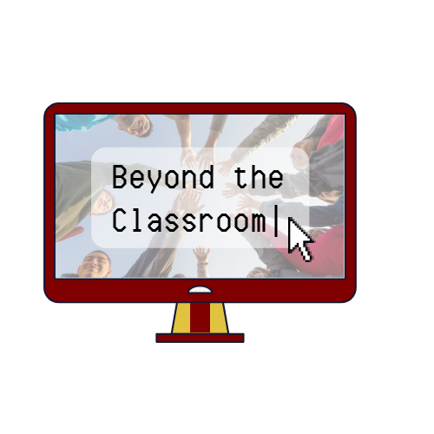
The proposed logo for the conference is designed above. The identified colors for the logo are maroon and gold, corresponding with ACE’s institutional colors from Gannon University. Using Gannon’s colors in the logo shows their support for the event, adding credibility to any claims. These colors are also easily identifiable by ACE’s target audiences. The graphic used in the logo is a desktop computer, a symbol associated with education. Computers are used immensely within the field of higher education. The font in the logo represents that of a search engine with computer script, giving the logo realistic qualities. Attention to details creates an image that appears aesthetically pleasing to the eye of the consumer, grabbing their attention. The image used in the background displays college kids outside of the classroom setting participating in a positive experience. The image could indicate that the students are participating in a service-learning based activity, projecting positive feelings around the topic in the minds of consumers. The proposed logo is eye-catching and communicates effectively to the target audience what the “Beyond the classroom” conference is. It can easily be converted to different sizes and black and white. Using this logo will help to brand the event as well as make it more identifiable to all audiences.
Campaign:
A public relations campaign is an organized course of activities aimed at distributing information and positively promoting the image of the organization. It is the action of maintaining a good reputation and keeping good relations and understanding between a brand and the public. The primary objective is to increase brand awareness in consumers through education. This will help to build a sense of loyalty within consumers, positively impacting sign-ups. A campaign will also help ACE establish its brand’s identity, establishing the brand in the industry by increasing its credibility. The central theme for this campaign will correspond with the big idea of “Beyond the classroom” to continue to practice IMC. Another objective specifically for this campaign would be to increase the number of attendees at this year’s conference. Utilizing a big idea centralized around a common theme through multiple promotional resources will help lead ACE to achieving their goal.
The campaign will be applied and monitored through multiple promotional and communication channels. These channels/methods include direct mail, social media, email marketing, and out-of-home advertising. The campaign will run from February 2023 to May 2023. The campaign will begin once speakers and topics are announced, and will conclude once registration for the conference ends.

- Marketing Communication Strategies/Tactics
  - Media Kit
It is proposed that ACE should create and utilize a media kit. A media kit is a set of promotional materials that provides information to those that work for various news outlets and the target audience. Media kits add credibility by including factual documents that these individuals can receive important information from. They also help to receive media coverage from various media outlets, further adding credibility to the organization. I believe that a media kit will be helpful also in relaying information to the target audience that may persuade them to attend the conference.
The media kit can be administered via email, or linked directly onto the Eventzilla website. Recipients of the media kit includes employees in the office of service-learning at designated institutions and Dean’s across all departments. Other recipients include those at local major media outlets in an effort to receive publicity. Using a media kit will help to comprise all relevant information into one organized place, rather than jumbled across visual communication pieces such as posters. Posters with less wording and more colorful visuals tend to grab the eye of the consumer over lengthy paragraphs. A media kit will help to combat this from negatively affecting the turnout for this year’s conference.
It is recommended that ACE uses Canva to design their media kit and all other promotional pieces. Canva is a user-friendly website at an affordable cost of $14.99 a month. The most desirable trait about the site is the “Canva Teams” option. Here, you can create and edit designs giving access to multiple users. This allows for more than one person to collaborate on a design. Furthermore, any graphics that I design for ACE can be accessed and edited on Canva at any point and time. The media kit will be designed minimalistically and aesthetically, communicating only necessary information to the target audience.
The proposed design for the media kit is as follows:
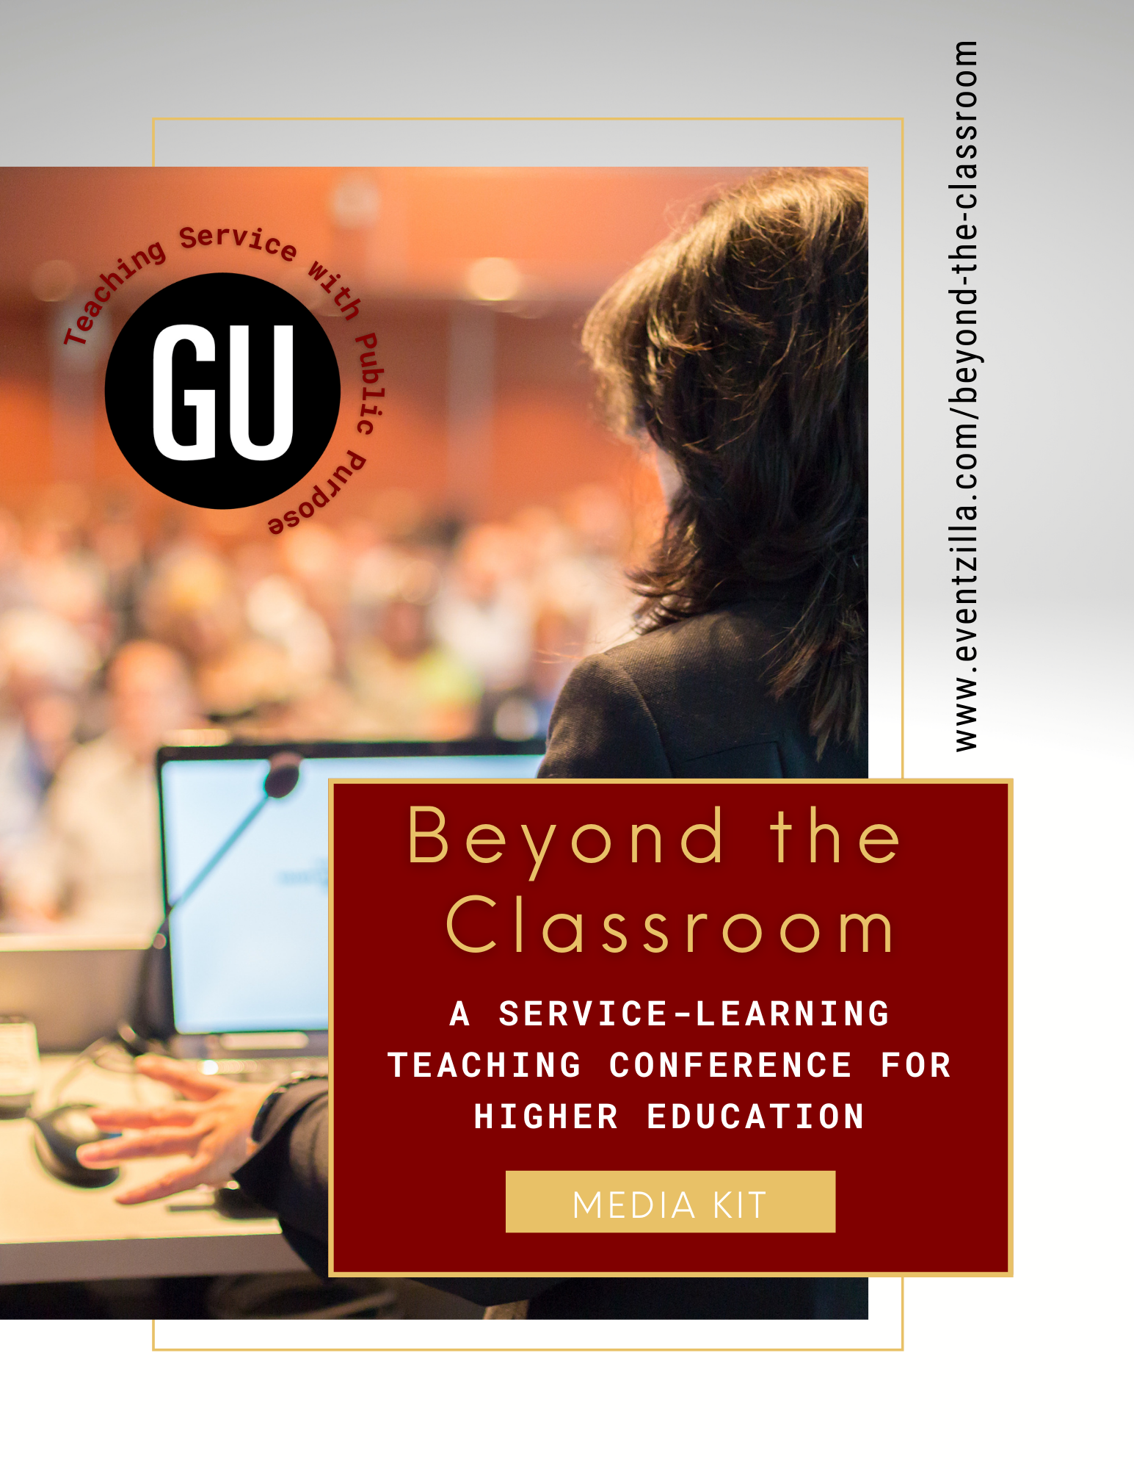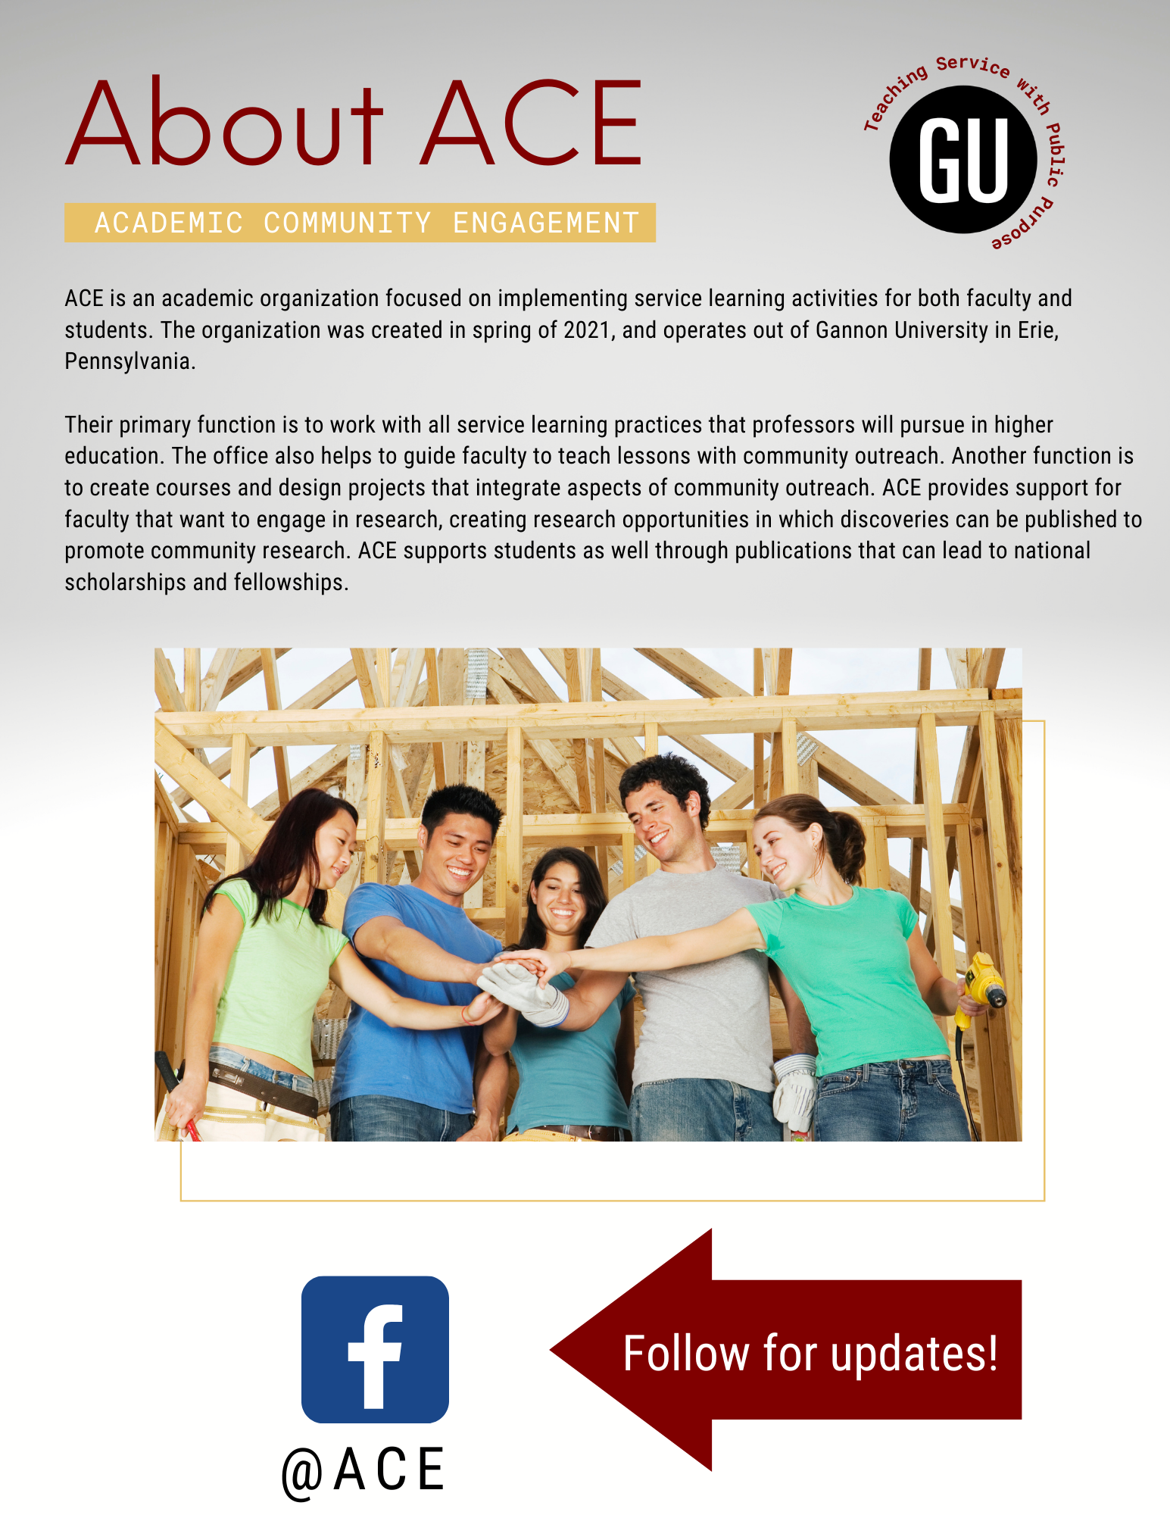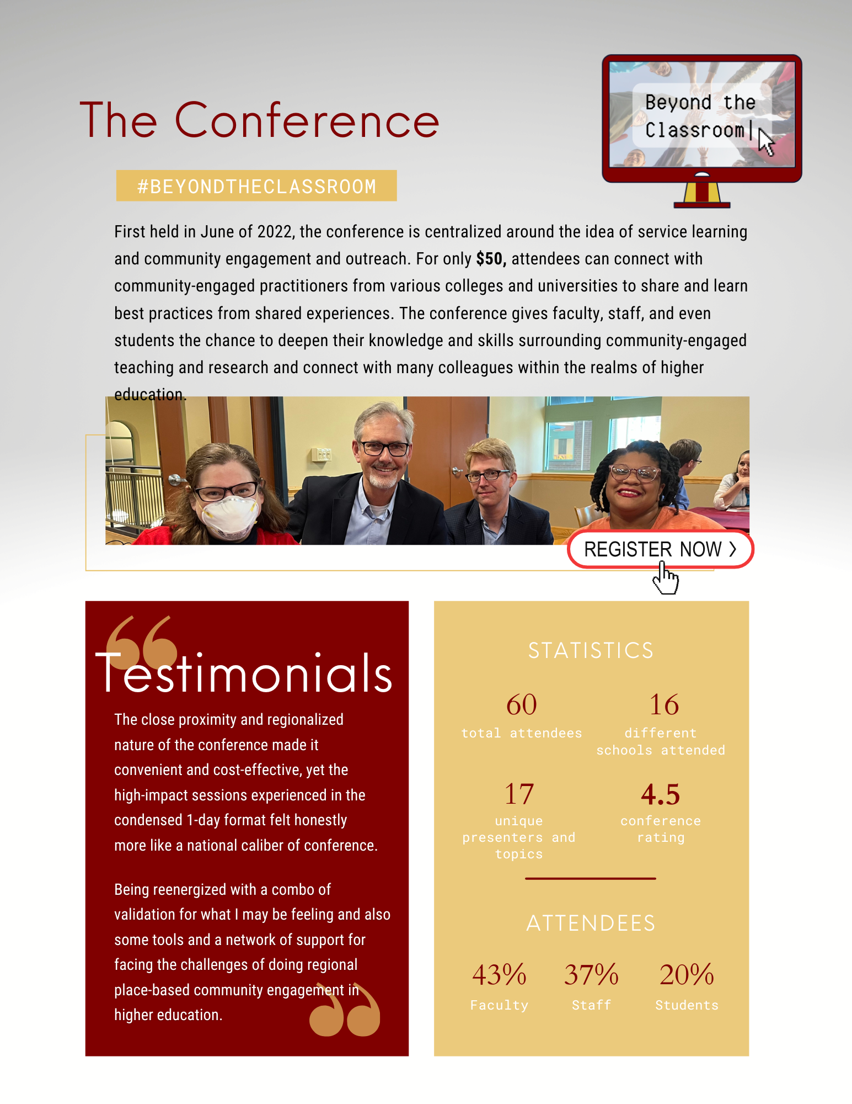
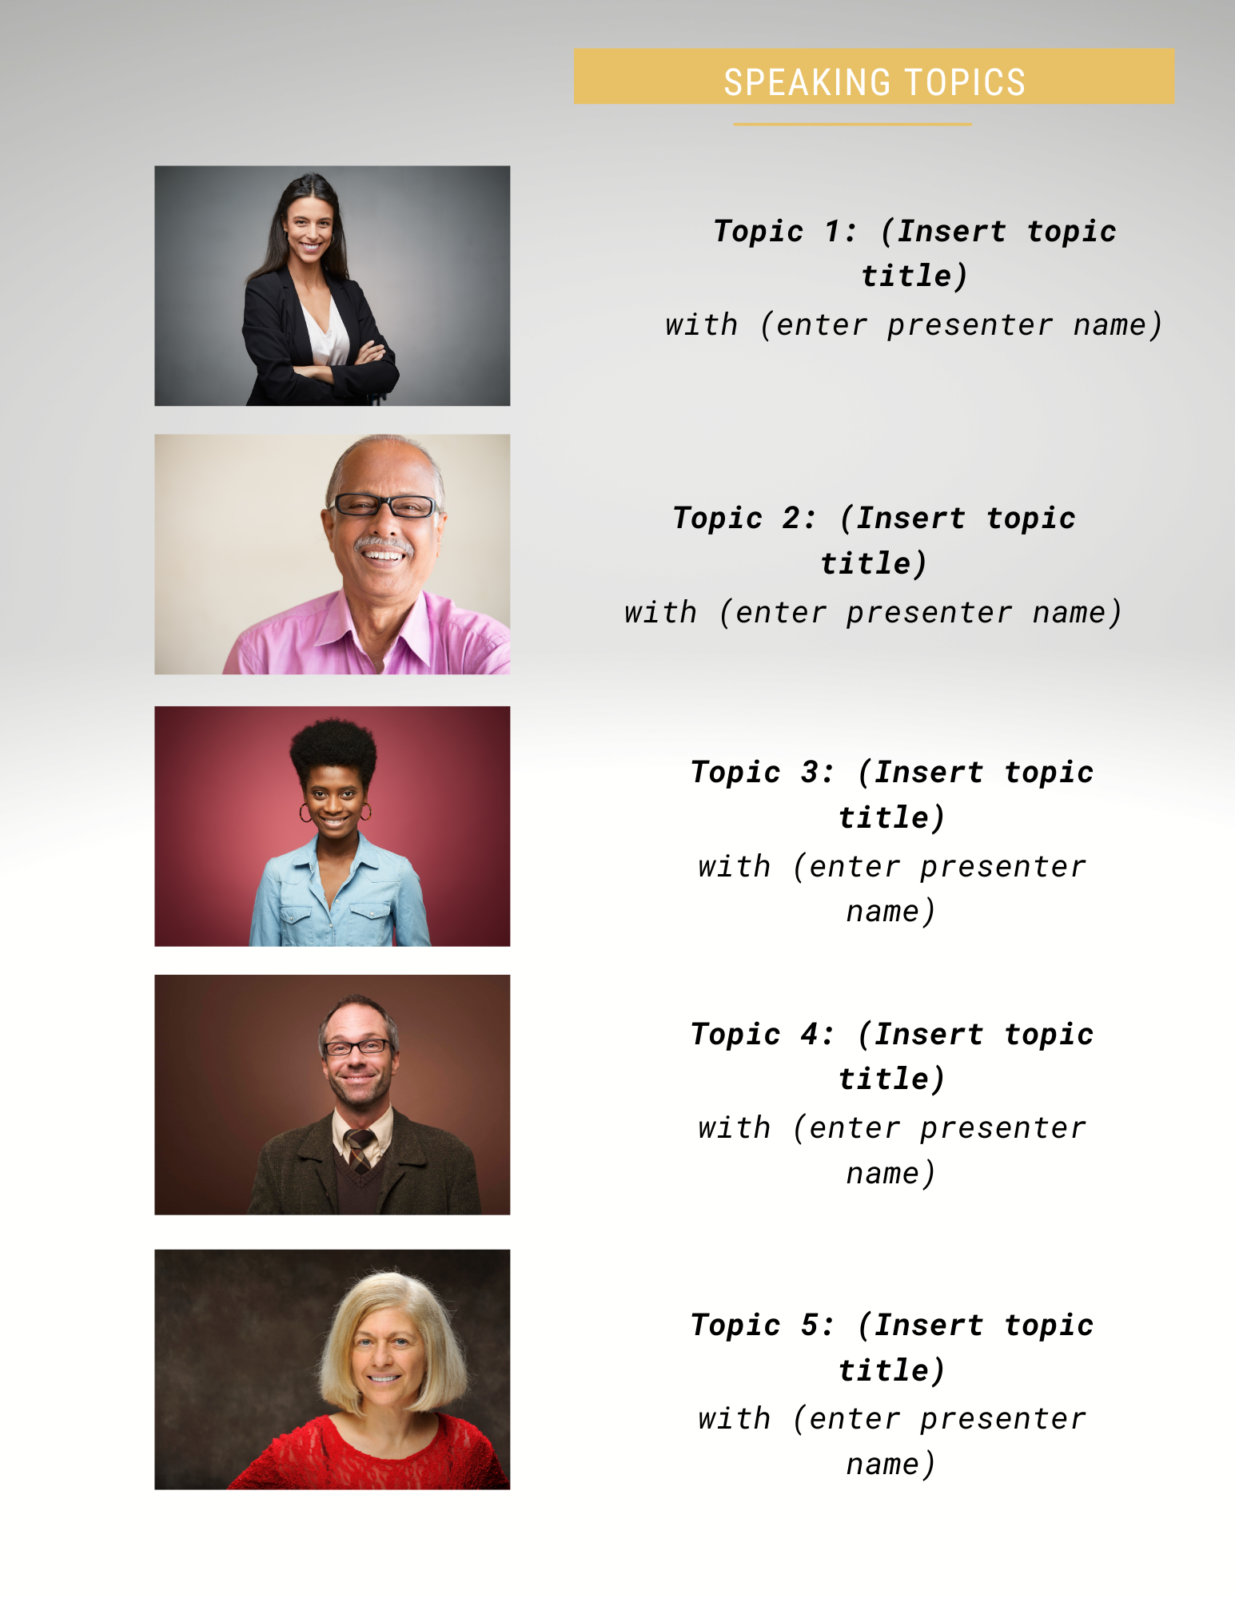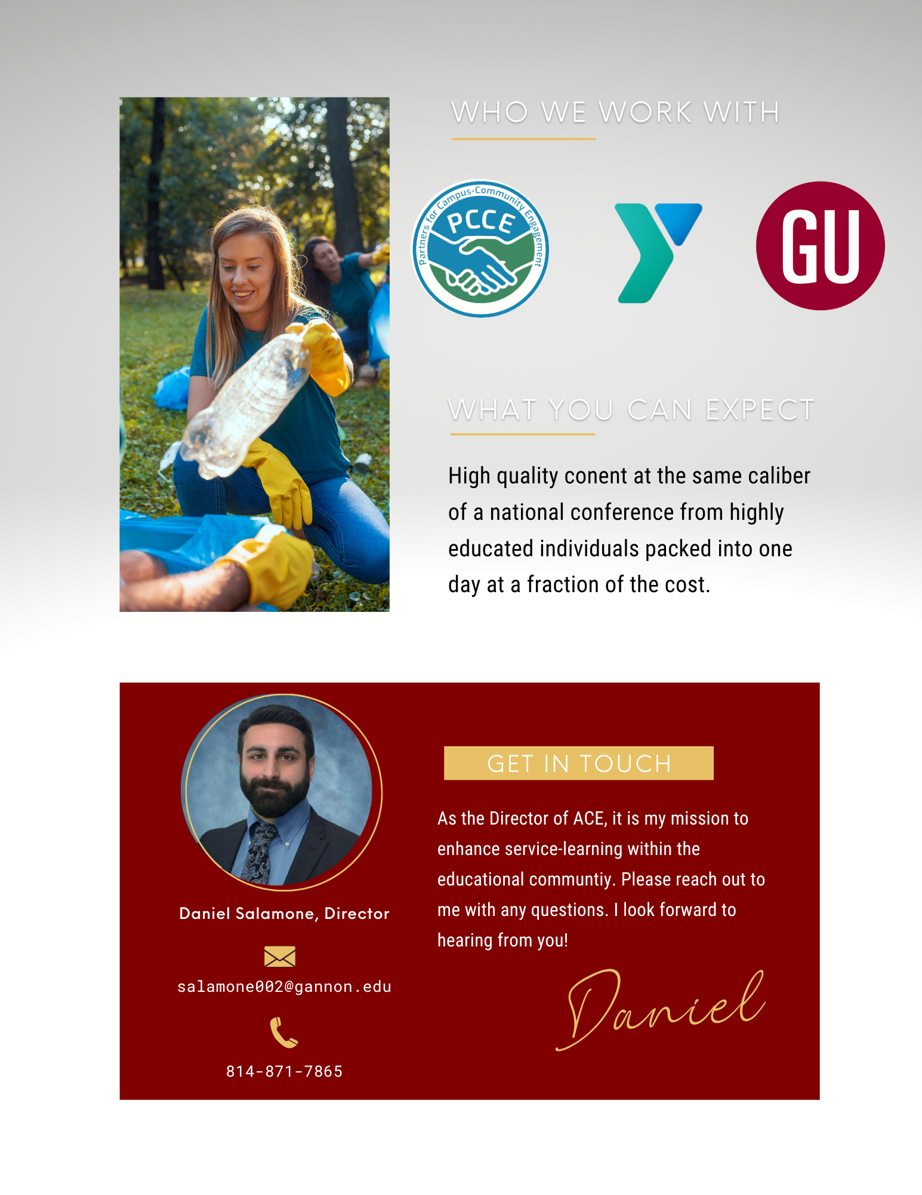

  - Email marketing
Email marketing is proposed to be utilized to send informative and promotional emails to current and potential customers. Emails can be used effectively to create databases, which consist of a list of consumers with information that helps target and segment those who are highly likely to be in the market for a certain product or service. Emails can also be used to keep consumers up-to-date on the latest news, keeping the organization consistently on their mind. This phenomenon is known as top-of-mind-awareness, which refers to the first brand that consumers think of when thinking of a specific product or service. This can help ACE become more of a household name in the service-learning world, leading consumers to make decisions that positively affect the organization.
Initial recipients of the emails will be individuals that work within the office of service learning at the various identified institutions, as well as the Dean’s of each department. These groups will act as the communicators, facilitating information out to faculty and staff, who can further communicate it to their students. This method of a trickle down flow of communication method will prove to be more effective than directly emailing each target audience member, as retrieving fully organized house email lists from universities can be costly and timely. Administrative positions play a strong part in influencing faculty and provide opportunities for further education. Utilizing them to pass along these messages to staff members and teachers will serve to be most effective and surpass issues of obtaining thousands of school emails. The students and teachers will receive informational messages that will inform them about the conference, explain why they should participate in the conference, and the promotional messages will provide a method for the identified audience to take action and purchase the service. The content will also stay with the big idea of “Beyond the classroom” and how this conference will help faculty teach service with public purpose.
Attendees that sign up for the event on the Eventzilla site will also start receiving emails to stay up to date, as well as establish and expand on the consumer-marketer relationship. It is suggested that one email to be sent every 3-4 weeks to the previously identified recipients. This quantity will not overwhelm consumers with spam content, but instead maintain awareness. Since the amount and duration of emails is minimal, purchasing a third-party monitoring service is not required. It is important to have a call to action on each email message sent, as this will lead consumers to the website to sign up for the event. Some examples of call to action include a website link, “register today”, or “found out more information”.The media kit can also be linked on the emails to avoid overwhelming consumers with too much information at once. This can act as a call of action again, leading consumers to the event site to view the media kit, and learn more about ACE. It is also important to have an attention grabbing heading, subheading, and visuals on emails to intrigue consumers to open it amongst all other clutter.
The schedule, topic, and graphics for email marketing is as follows:
- February- 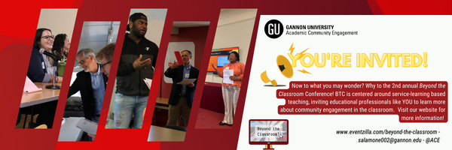
- March- 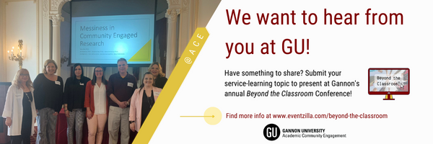
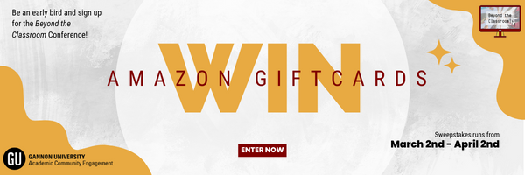
- April-
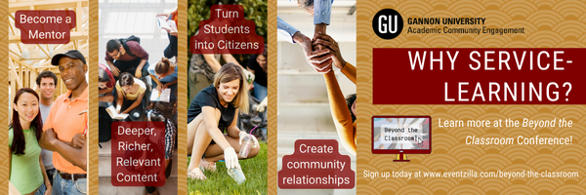
- May-
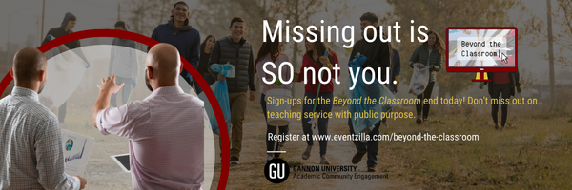
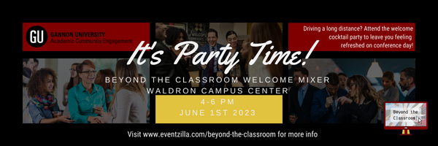
- June-
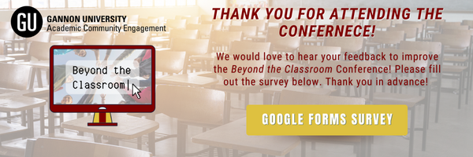

  - Social Media
It is recommended that ACE utilizes social media to market the “Beyond the classroom” conference. The social media platform that is suggested to use is Facebook. The organization does not have any current active social media accounts. However, the organization in which they were formed from (The office of service-learning) still has an active Facebook page. The page at 525 likes and 559 followers offers a stable basis to begin posting social media content on. Therefore, ACE is recommended to rebrand Gannon’s old service learning Facebook to the Office of Academic and Community and Engagement. On top of already having a following, Facebook is the mostly used social media platform by the primary target audience. Subsequently, the secondary audiences notably use the platform, allowing for promotional messages to reach all audiences through it.
To keep with an integrated marketing strategy, it is recommended that some mechanical aspects on Facebook are changed. The profile photo for the social media should also be changed to the newly designed logo, with the ACE logo as the header. Furthermore, the account name will be changed to ACE with contact information updated to President Daniel Solomon. Additionally, the new slogan and the date of the conference will be added into the biography. The page will solely be dedicated to marketing the “Beyond the classroom” campaign to promote the conference, sticking with content centralized around that big idea.
Frequency is a crucial aspect in any organization’s social presence. Finding the perfect combination between posting too much or too little is important in establishing a strong social media image. With the right frequency, reach can be increased, allowing for more users to be exposed to ACE’s message and the conference. It is recommended that ACE posts on their normal feed three times a week. This will allow for them to stay active, building a consistent online image without bombarding their followers’s feeds. The suggested weekly social media schedule for ACE’s social media is as follows:

Post 1: Mondays.
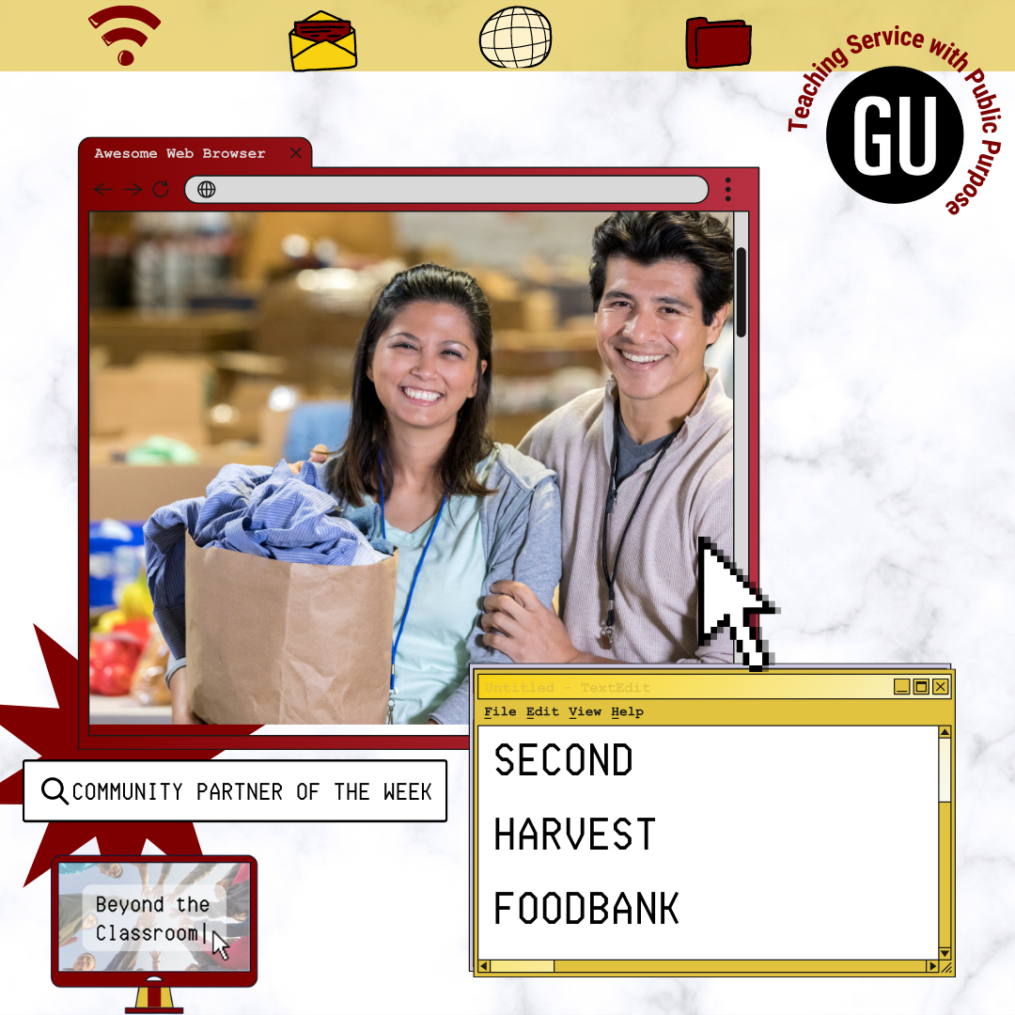

This will feature a computer screen with an image of the selected community partner to be featured for the week. The post will outline what they do and how ACE has worked with them in the past. Details included in the copy of the post.

Post 2: Wednesdays.
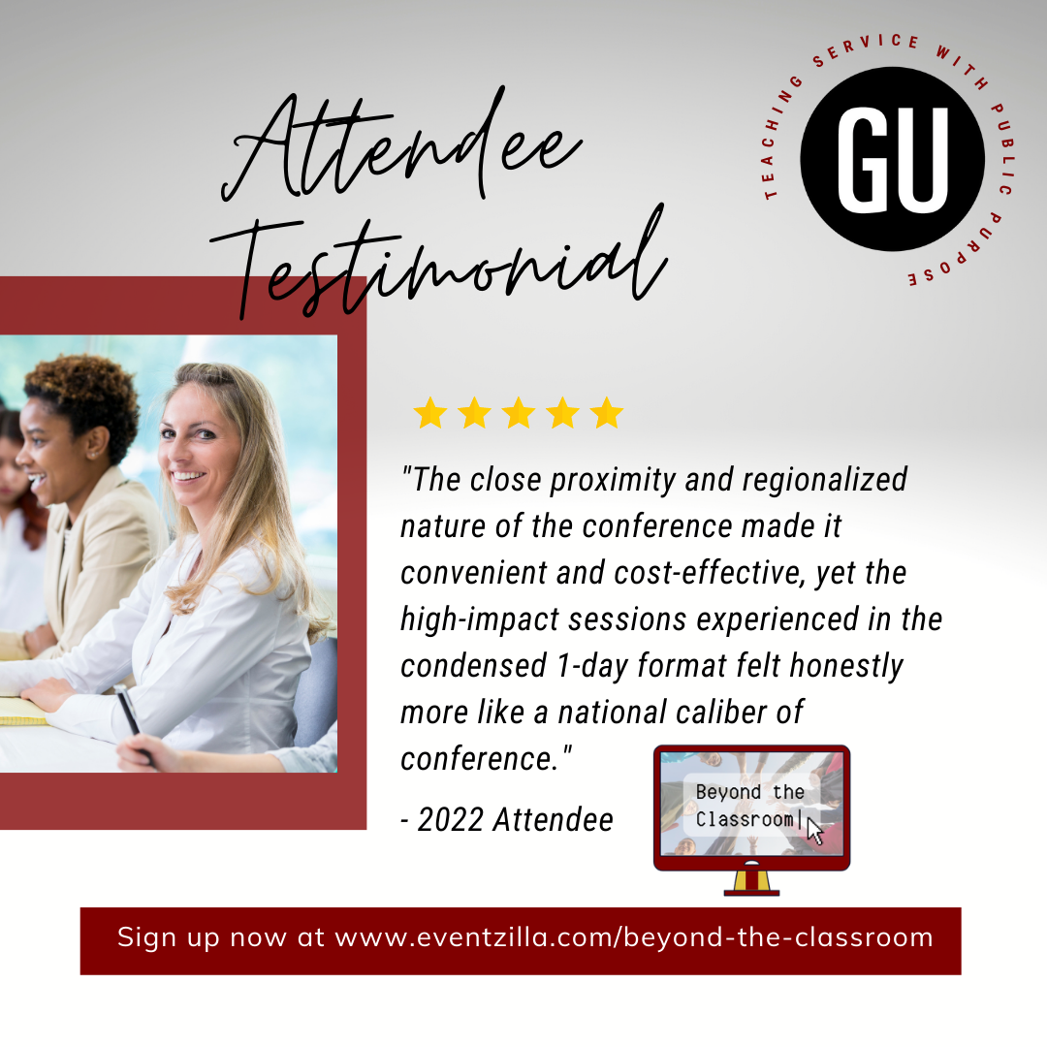
This post will feature different customer testimonials. Each post will have a template, allowing for the content to be easily edited and managed by student workers. Using testimonials will add credibility to ACE’s claims.

Post 3: Fridays.
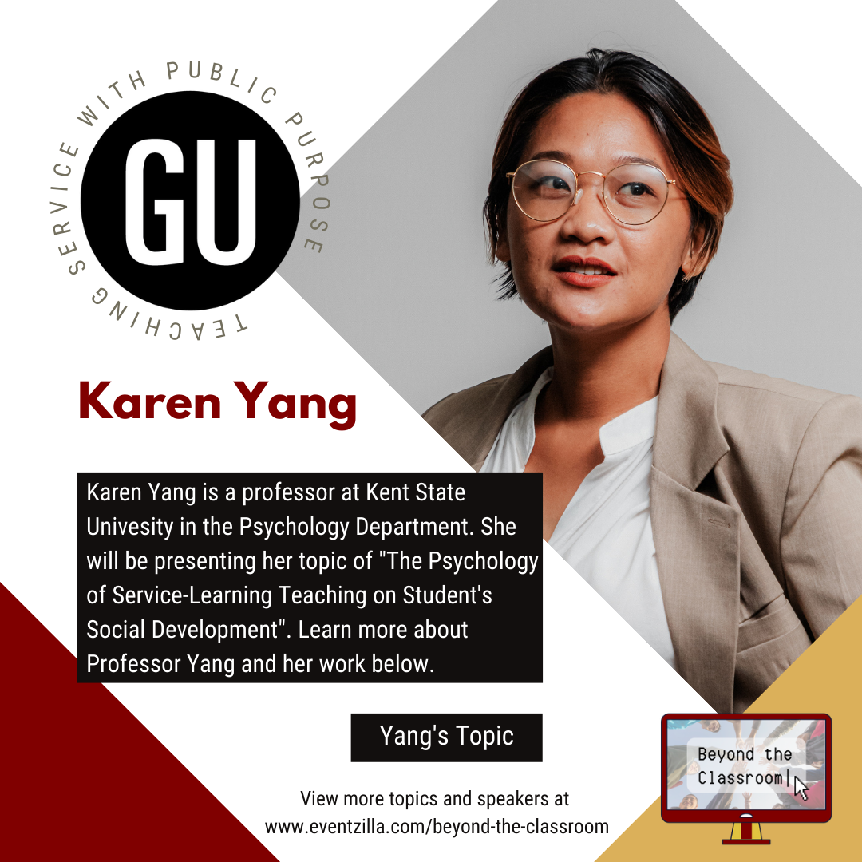
The last post will showcase one of the speakers and their topics. This will create excitement around the presentations as well as piqued potential consumer interests to visit the website to read more stories.

It is one of my personal professional goals to reinvent the way users look at social media management from a chore to a skillful tool. This can be achieved through the use of a website called Later.com. Later.com is a social media management site that allows for organizations to easily schedule out their posts for their social media channels beforehand. This will allow for ACE to follow through with their social media strategy and schedule out posts in advance. Since posting initially is minimal, the premium subscription for the site is not necessary. Instead, ACE can maximize their budget through using the free version, as it offers enough services to achieve what is needed. The site is also very user friendly, allowing for it to be easily used by anyone at the organization. The combination of a strong social media posting strategy with a consistent schedule will lead to expanding their success on the social front.

  - Direct Mail and Direct marketing
I recommend sending out a direct mailing piece to the same recipients as emails. Like the same concept with the emails, sending out direct mail directly to each primary target audience member would exhaust most physical and financial resources. Therefore, office administrators and Dean’s will be used again to pass along marketing messages. Sending out direct mail is a very essential part in the direct marketing process. It informs the customer about a product or service (like the conference) and gets their attention, while providing reasons why a customer should participate in the event. Print communications are designed for the human eye to easily follow and read along. The copy on this piece should not be great in length, getting right to the point. Additionally, graphics on print communications should be compelling and vibrant to grab the attention of the reader. Print communications should provide information about an organization and its products, establish lead generation, and have a strong call to action.
The type of direct mail piece that will be sent out will be in the form of a postcard. This is planned to be sent early on in March of 2023 to create excitement around the event, including aspects of lead generation that will influence them to sign up on the website. Each institution will receive 12 copies each in faculty mailboxes and on tables in common areas. These copies can be printed at Gannon University using facility resources to lower costs and mitigate the budget for the other needed areas. Postage can be received at an extremely low cost via postcardmania.com, which provides postage for as little as 5 cents per post card.
Utilizing a creative visual like this for the communication piece can act as an initial physical push for consumers to take action from its eye-catching and unique qualities. Postcards will be ensured to include the website link to lead consumers to find out more information and sign up.
An advantage to direct marketing is it will help build relationships with faculty and staff and keep them engaged, provide information on ACE and the conference, and provide a call of action to attend and maybe even submit a proposal. This will help ACE to achieve their objective of building stronger consumer relationships with consumers as well as increase the number of attendees for the conference this year.

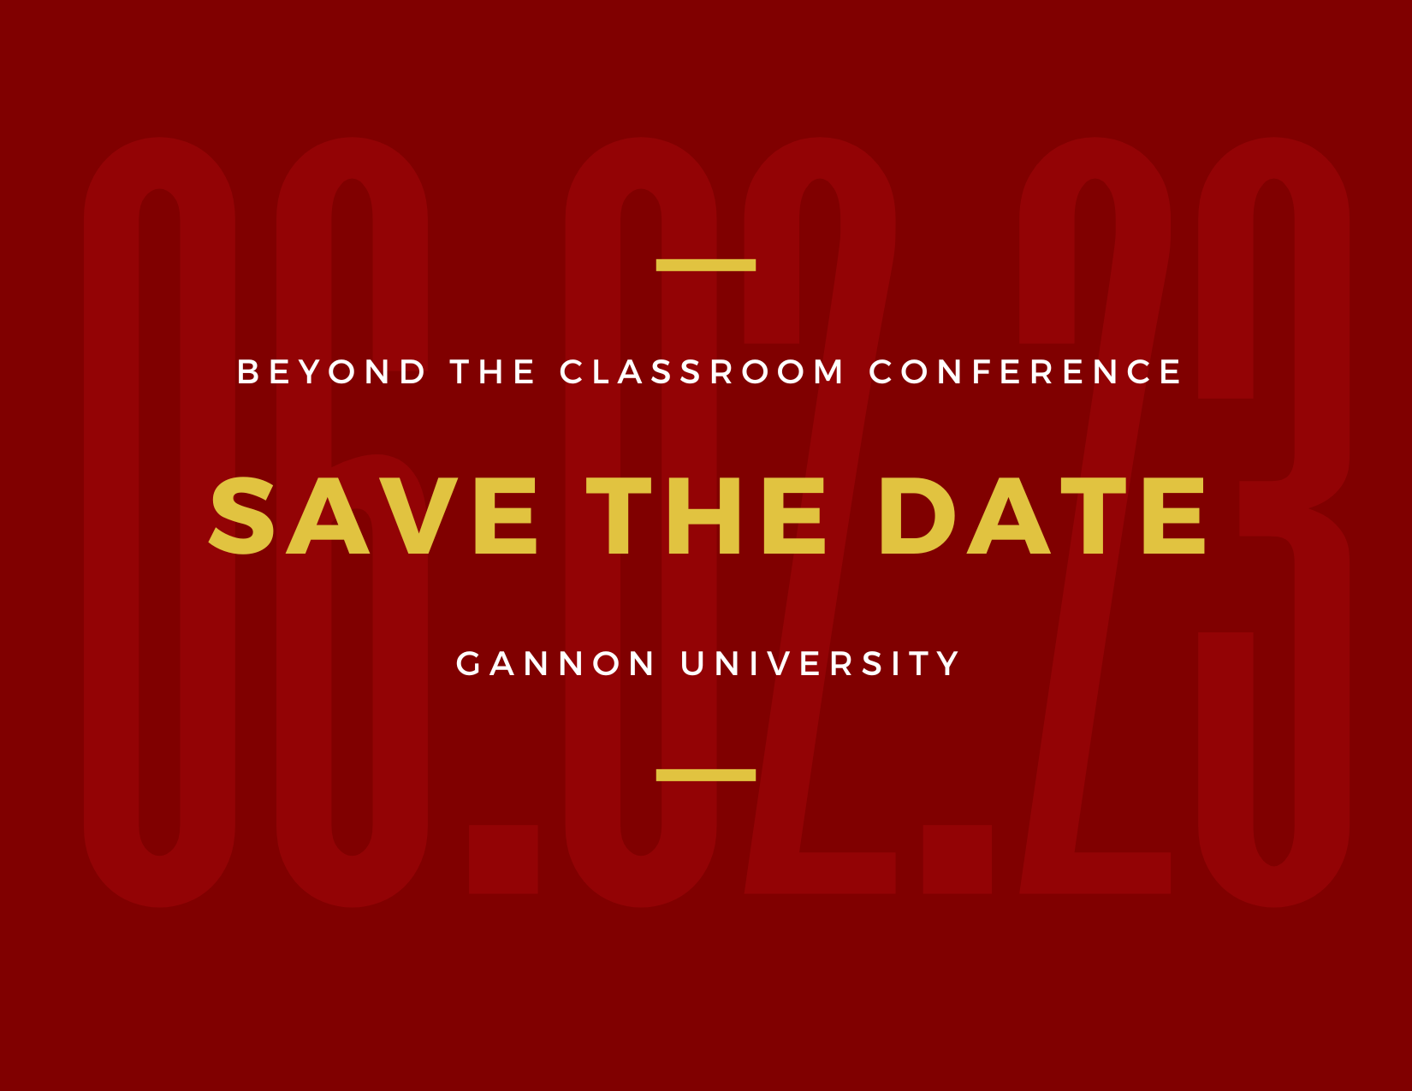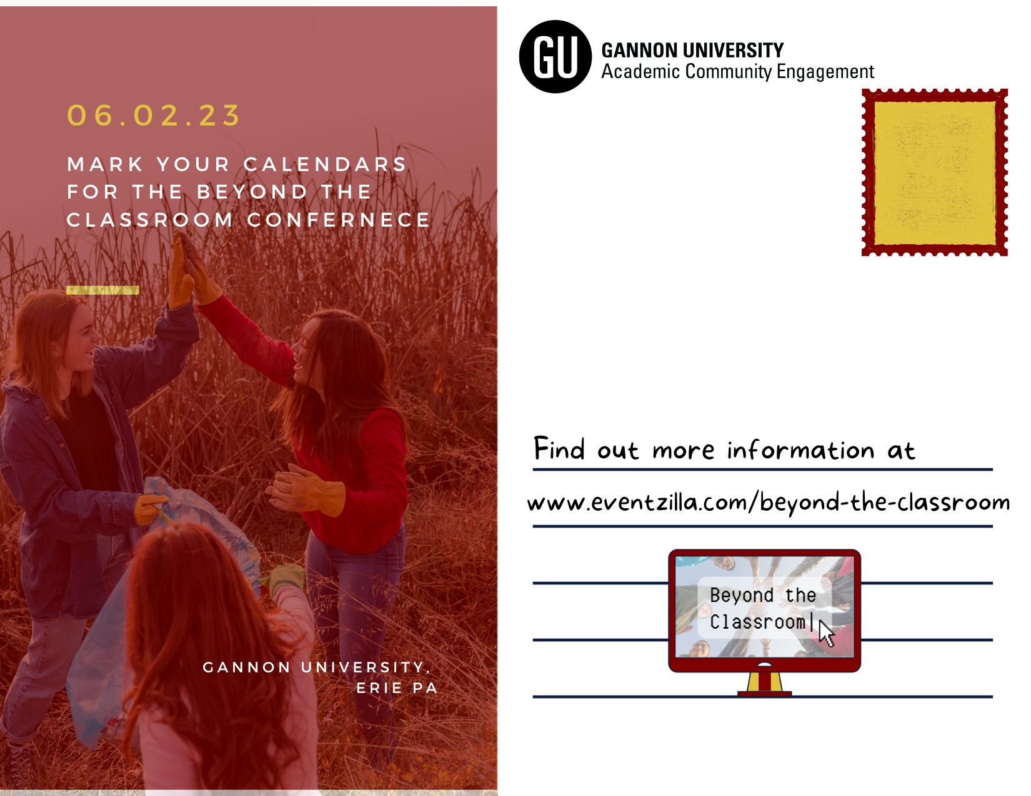

  - Out of home advertising
Out of home advertising refers to any form of advertising that a consumer views outside of their home. Outdoor advertising comes in various forms. For the purpose of this campaign, it is recommended that posters are used. This will be an effective form of advertising as out of home can reach a large number of consumers for a long period of time. Furthermore, out of home advertising cannot be deleted or closed out in comparison to digital advertisements, masking the frequency of the communication message more constantly. Posters are effective in getting the attention of consumers and communicating important information to them in a visually creative way.
The key to out of home advertising is to place them strategically at locations that will reach the proposed target audience. Consumers that ACE wants to target spend their time mainly at educational institutions in the tri-state area of Erie County. Based on this knowledge, it is determined the best place to administer these posters would be to Ohio, New York, and Pennsylvania colleges and universities. Selected colleges will receive 2-3 posters to display in heavily trafficked areas by the target audience. Some places include main entrances, bathrooms, cafes, or lounges. To lower costs, posters can be printed at Gannon using university resources. However, it is recommended that posters are sent to a third party vendor to be printed on higher quality paper to achieve a more professional look. A potential printing vendor to use is uprinting.com, with 500 8.5 x 11 posters for 29 cents each for a total of $143.55.
Information on this poster will include general information about the conference, as well as the event logo and slogan to stick with an integrated strategy. The theme for the posters will also correspond with the big idea “Beyond the classroom” to coincide with the IMC. The posters will help to educate consumers, grab their attention, and keep ACE at the top of the minds of college faculty and staff leading them to sign up and attend.

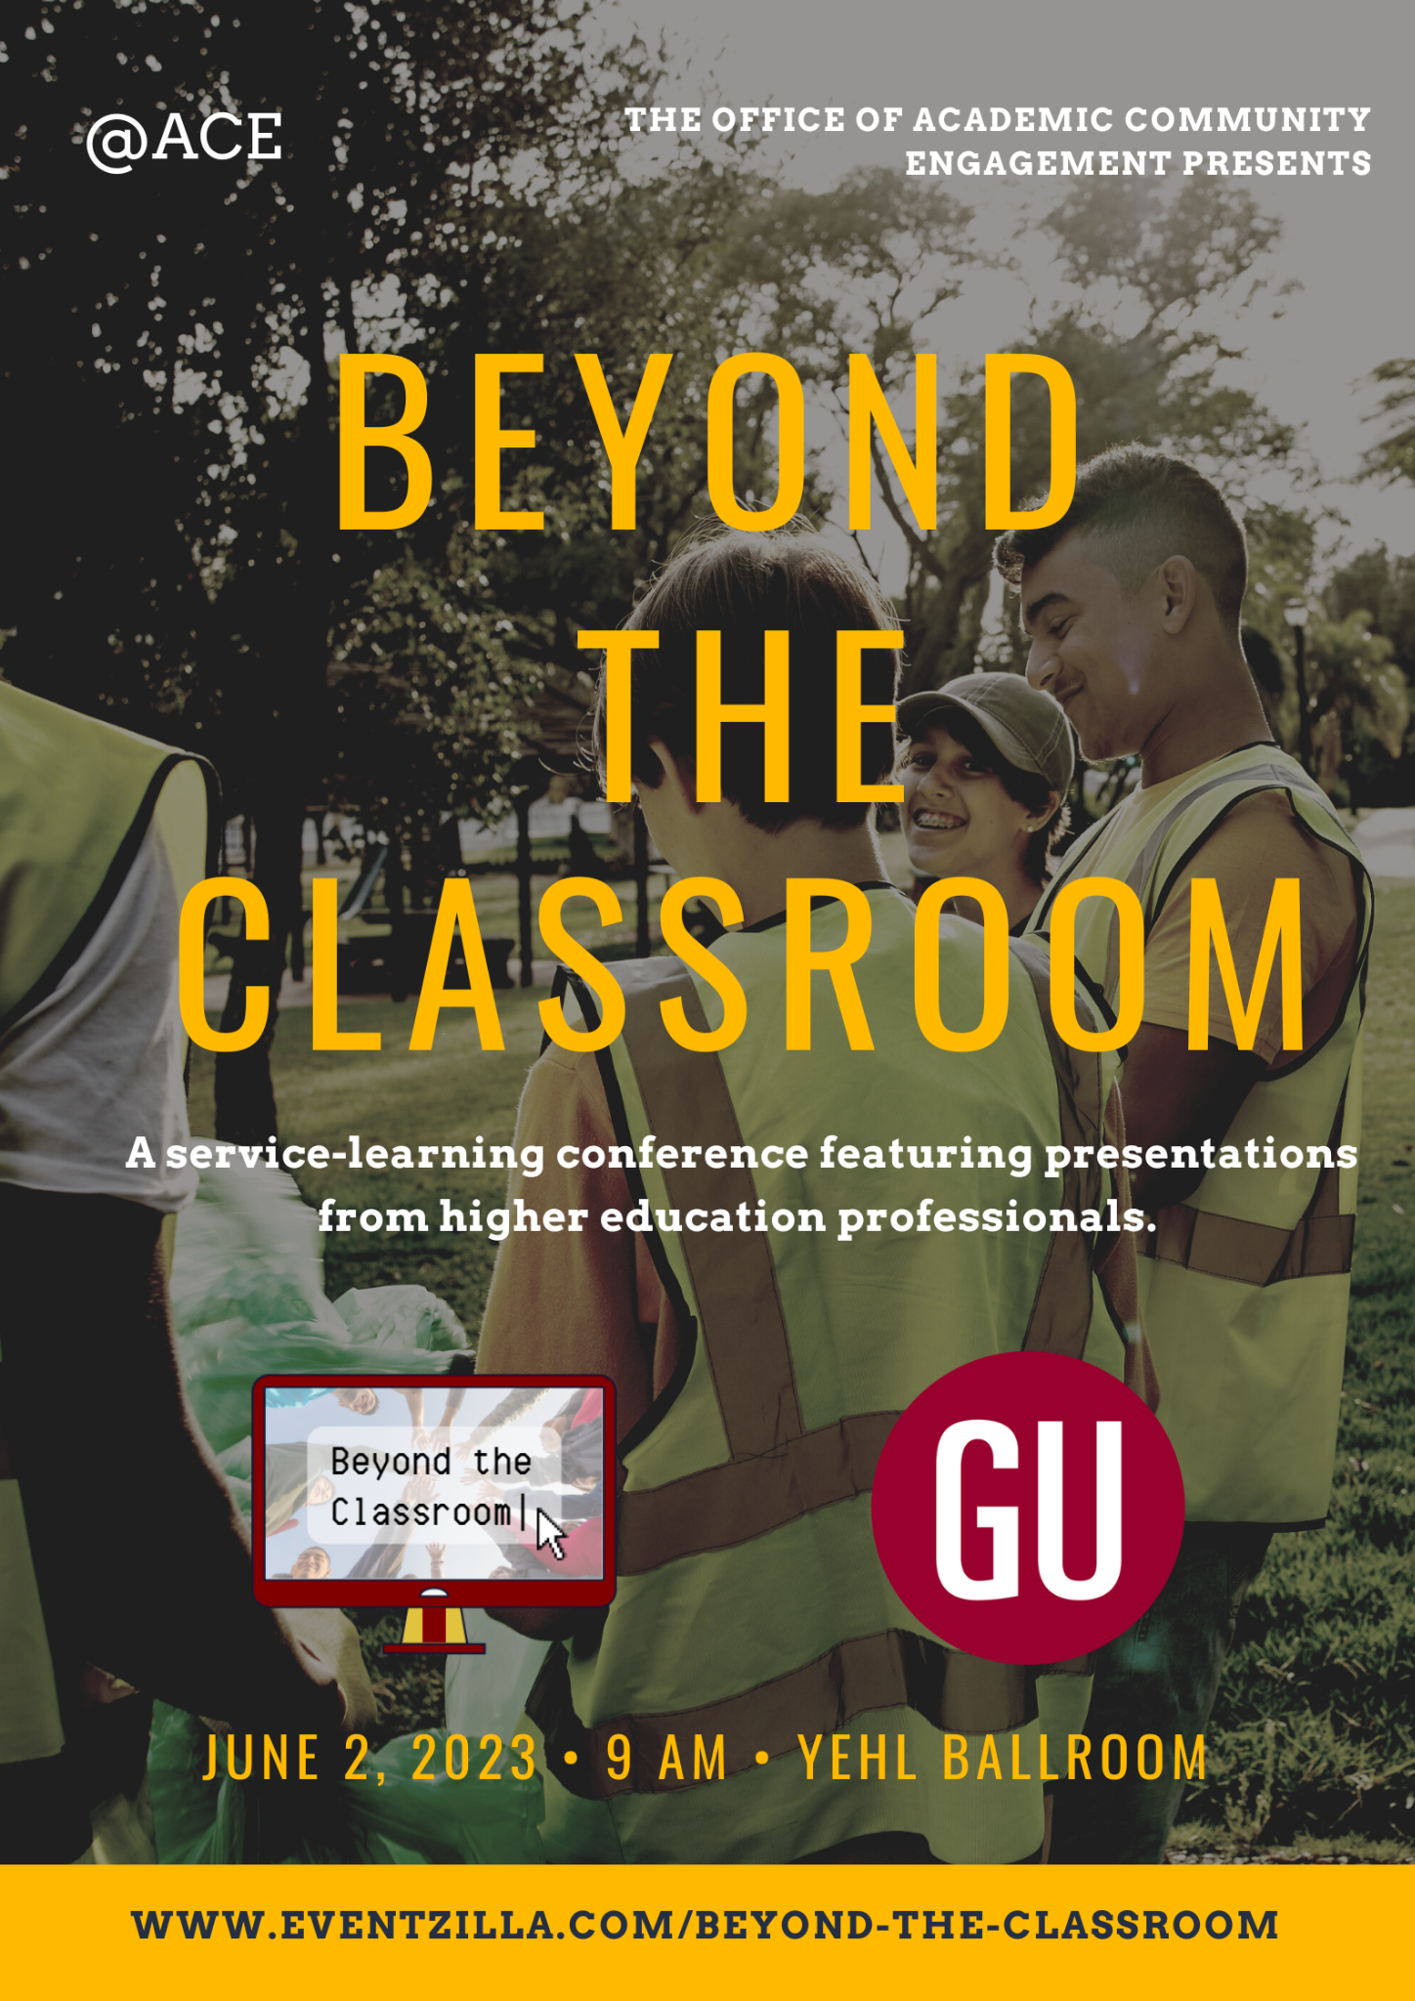

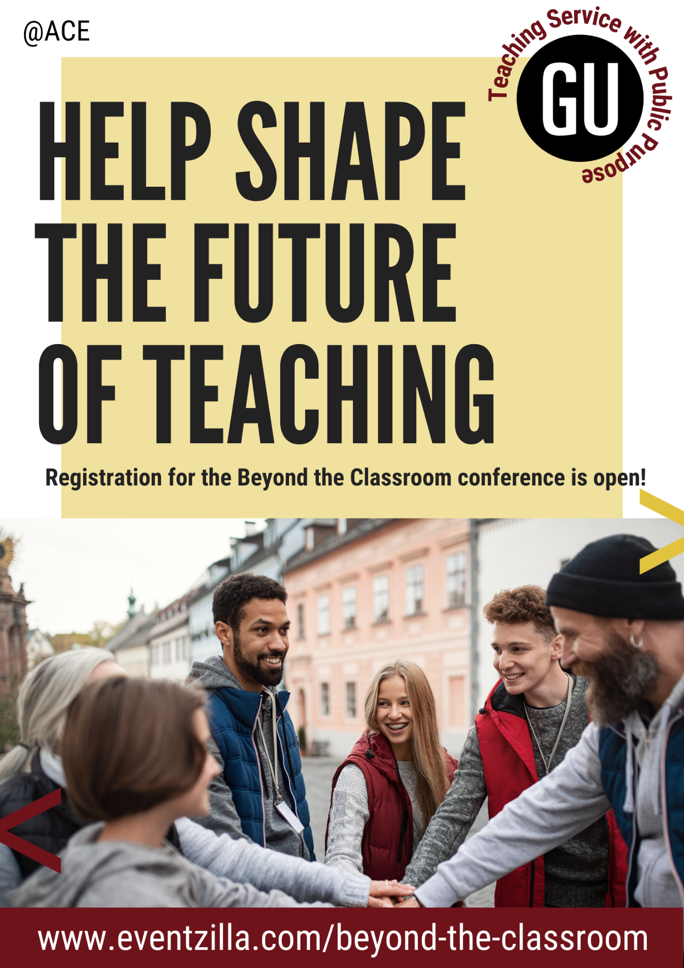

  - Redesign program
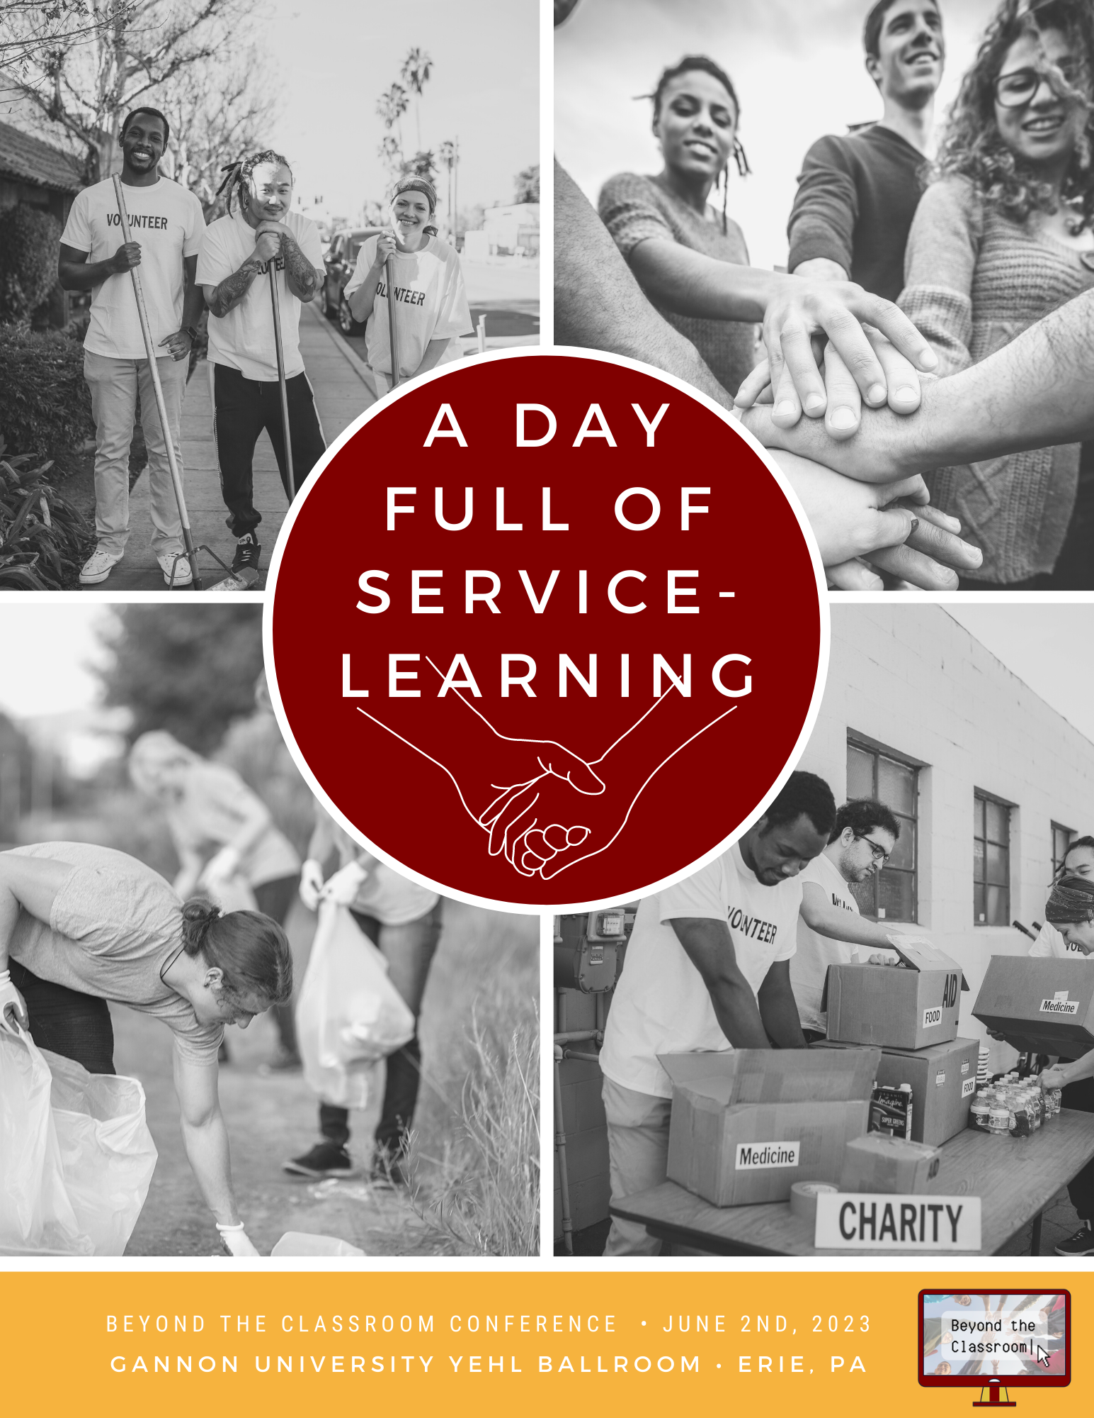

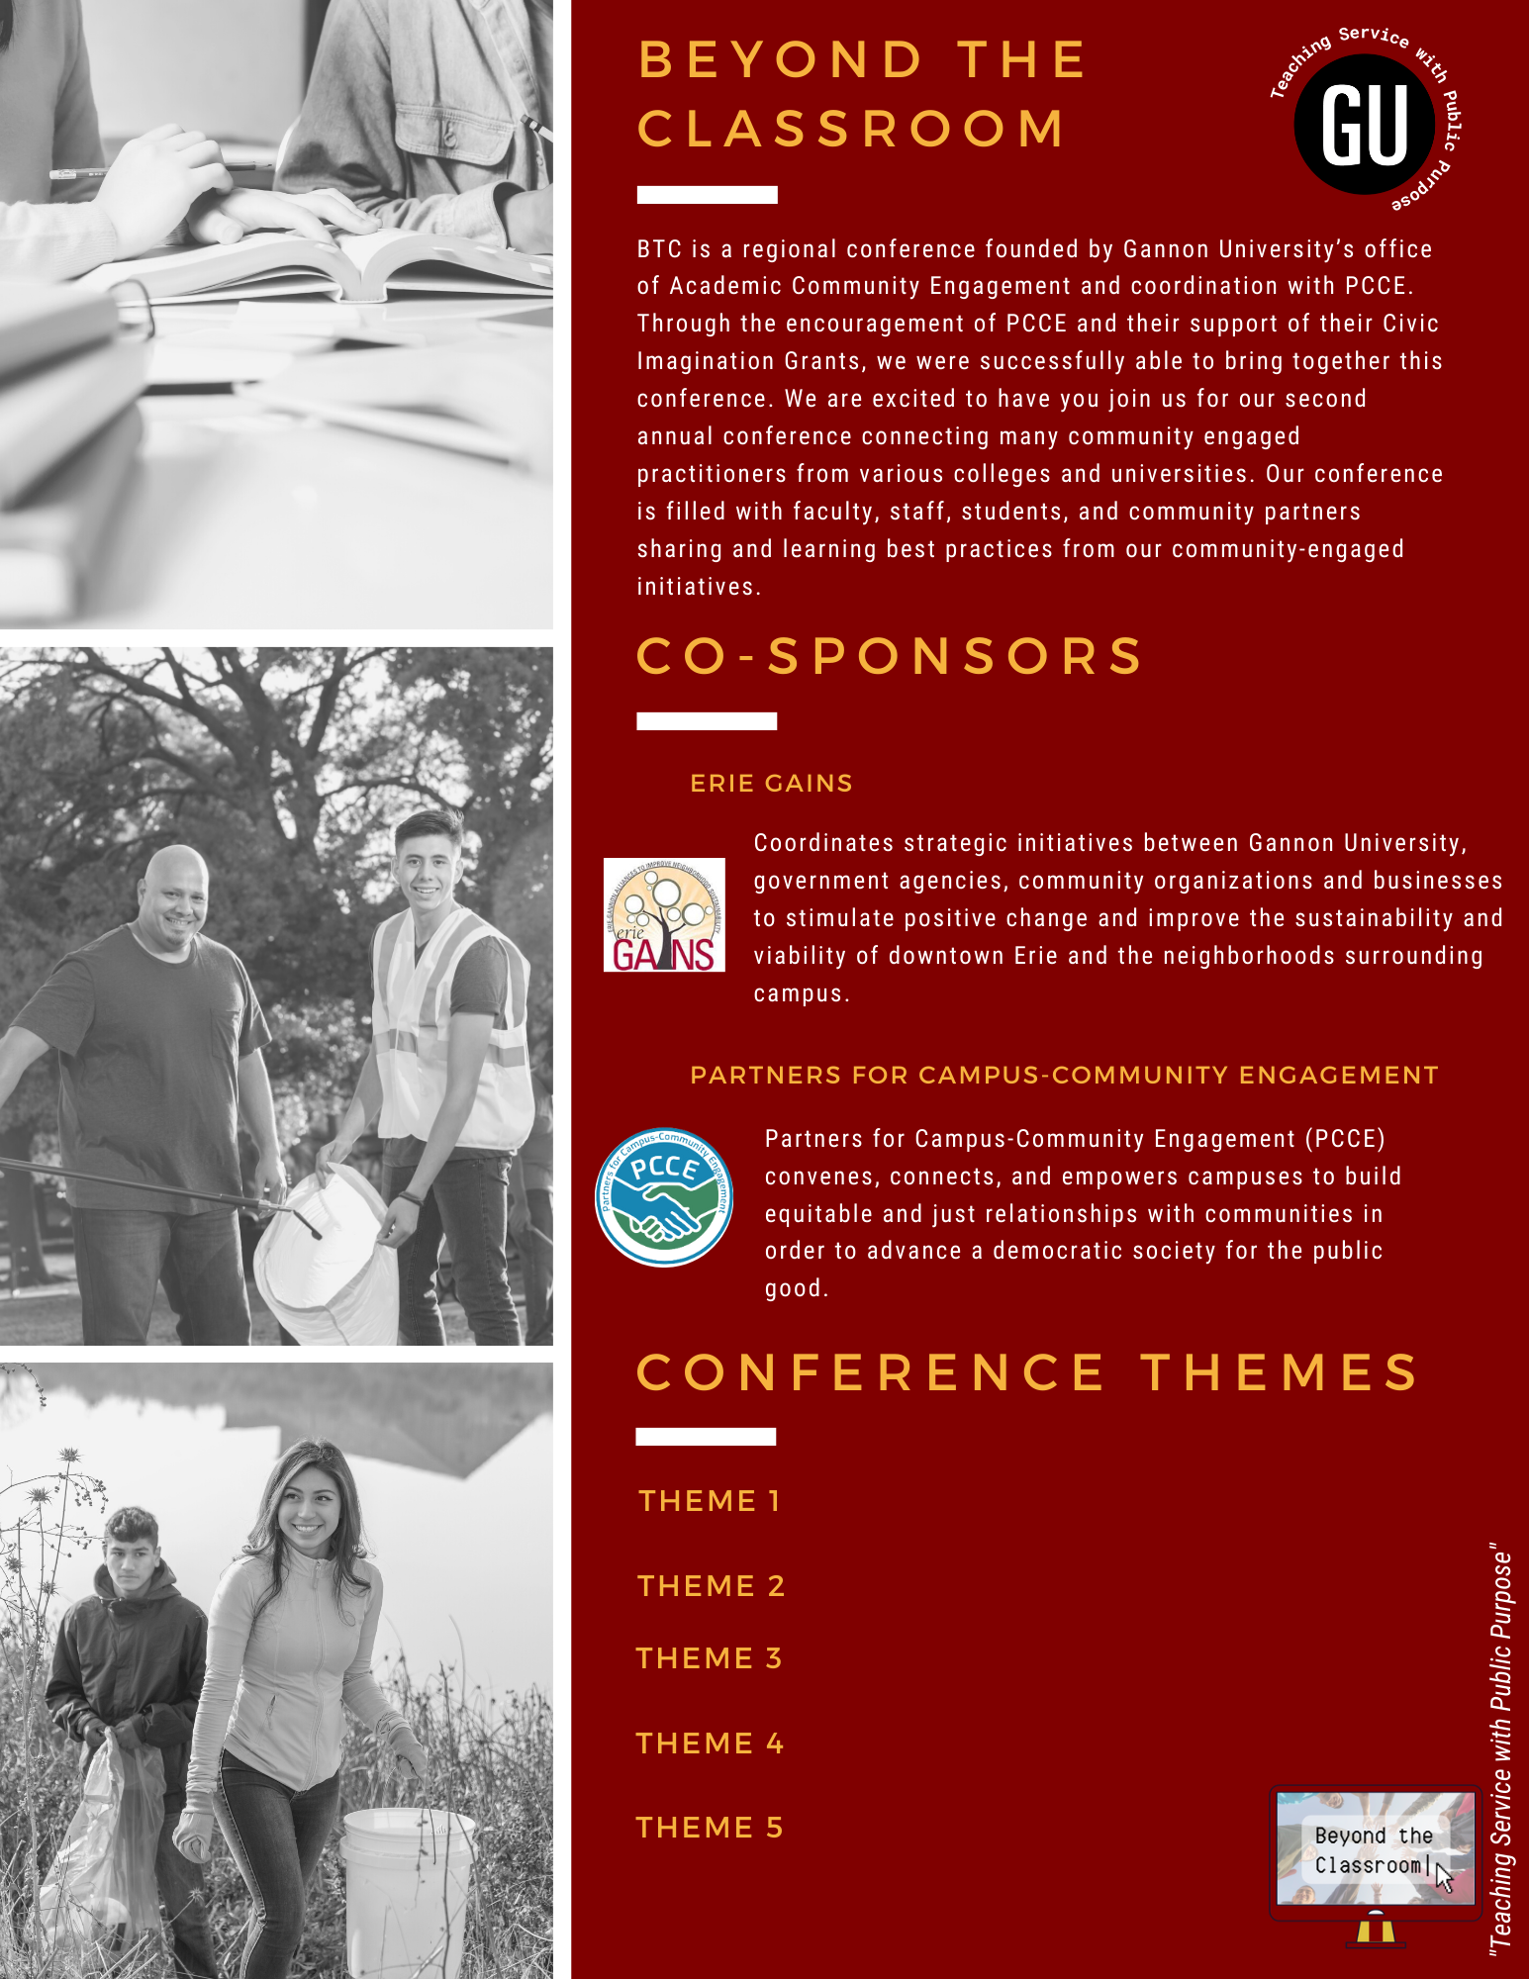

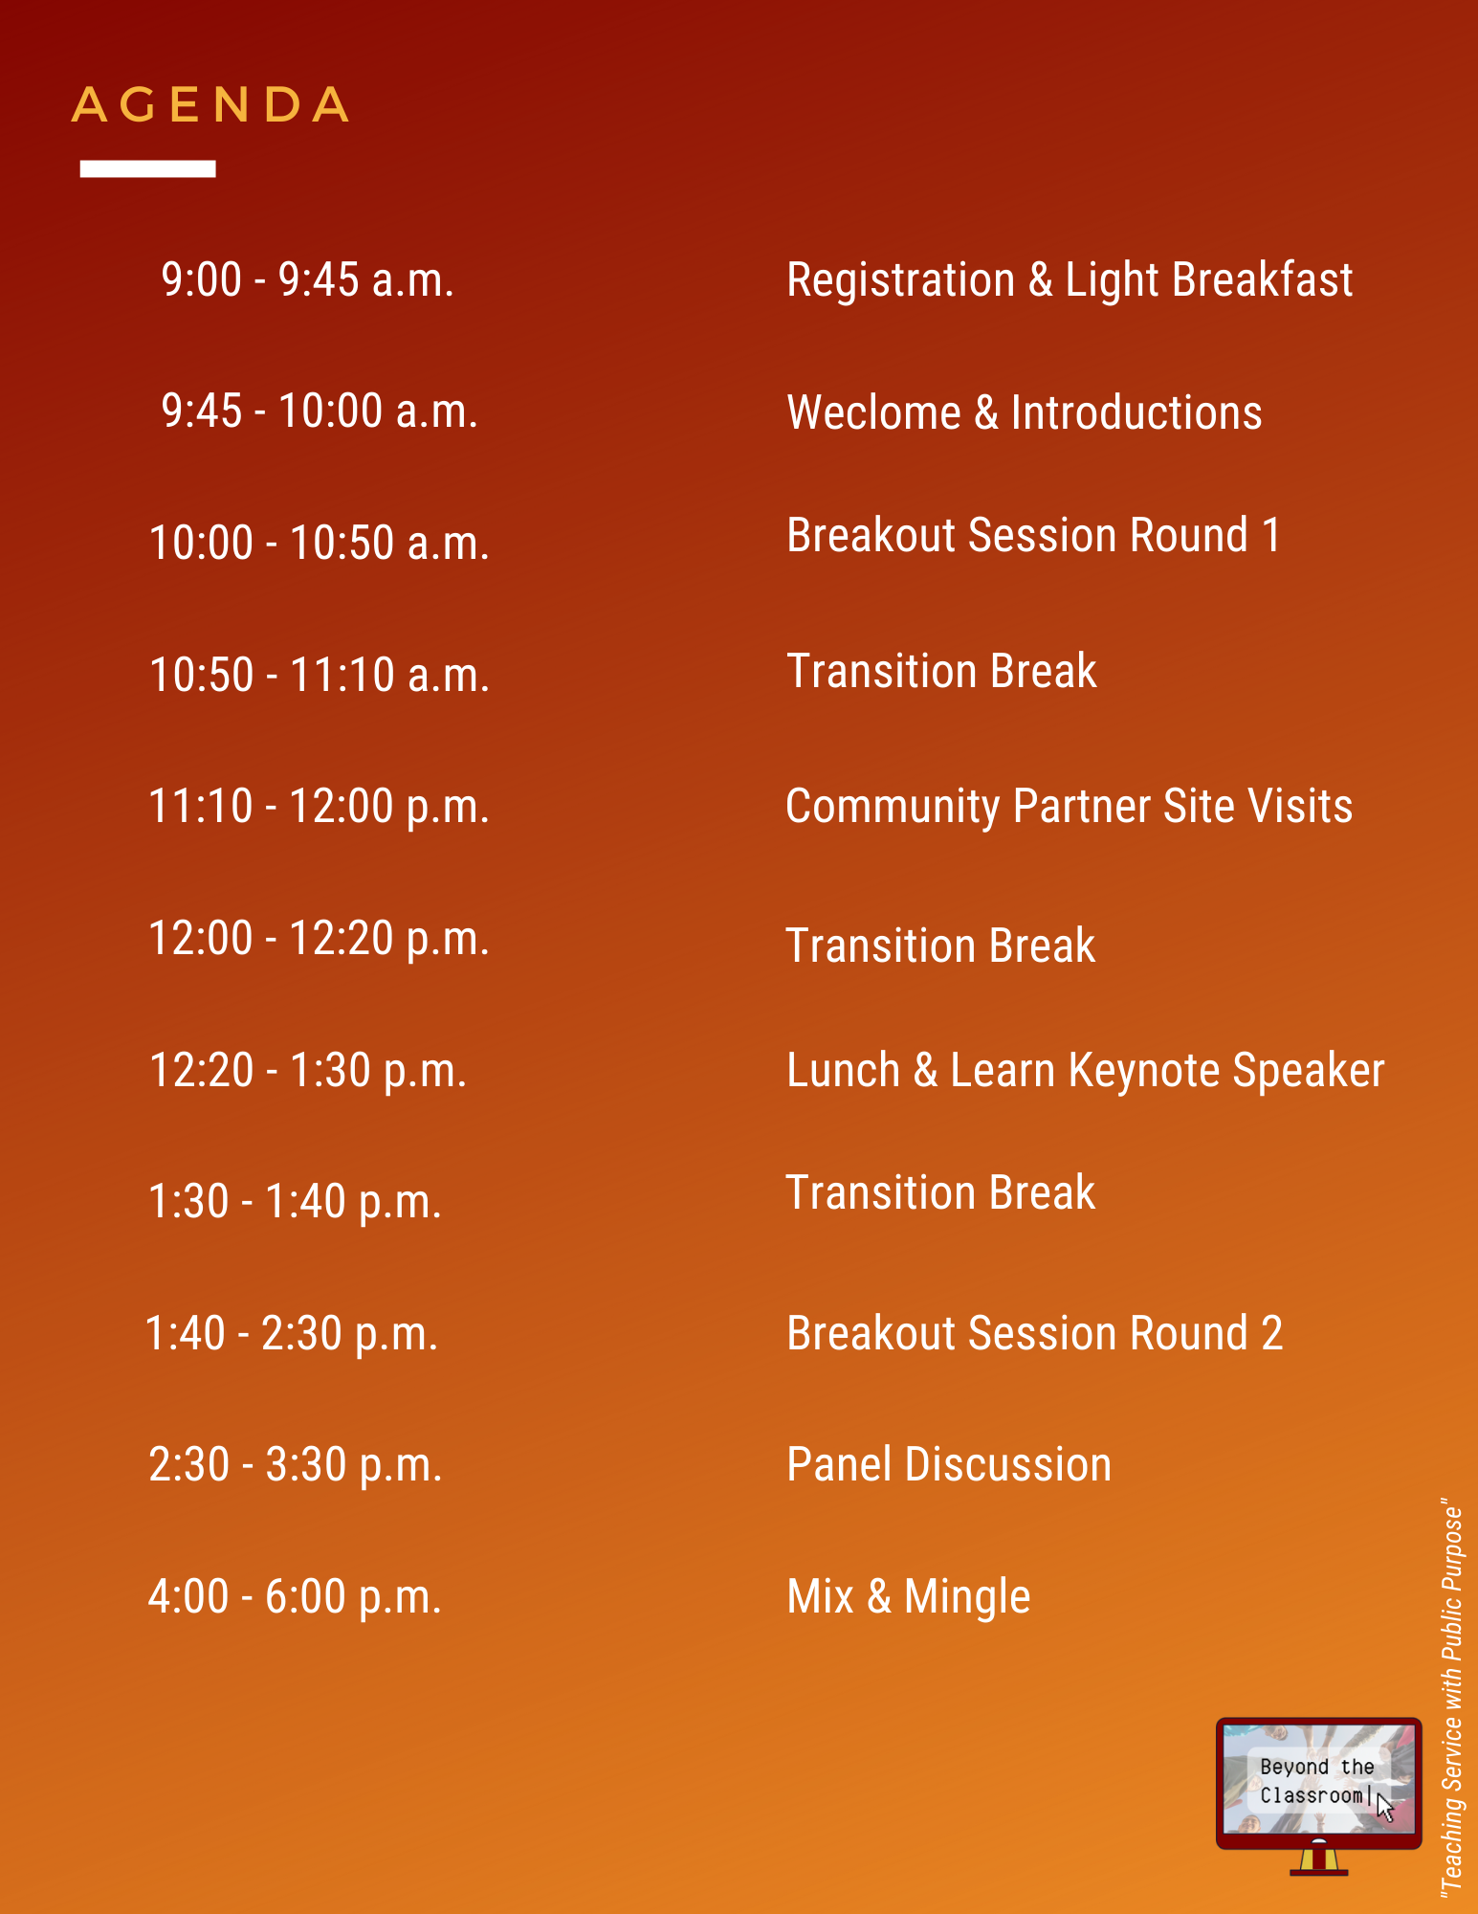
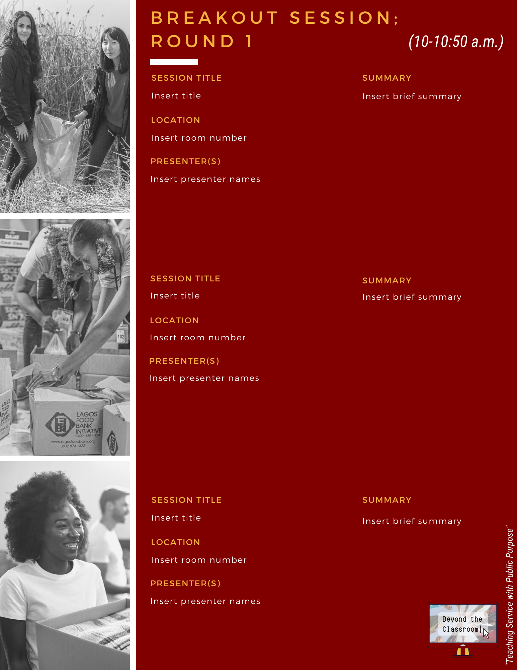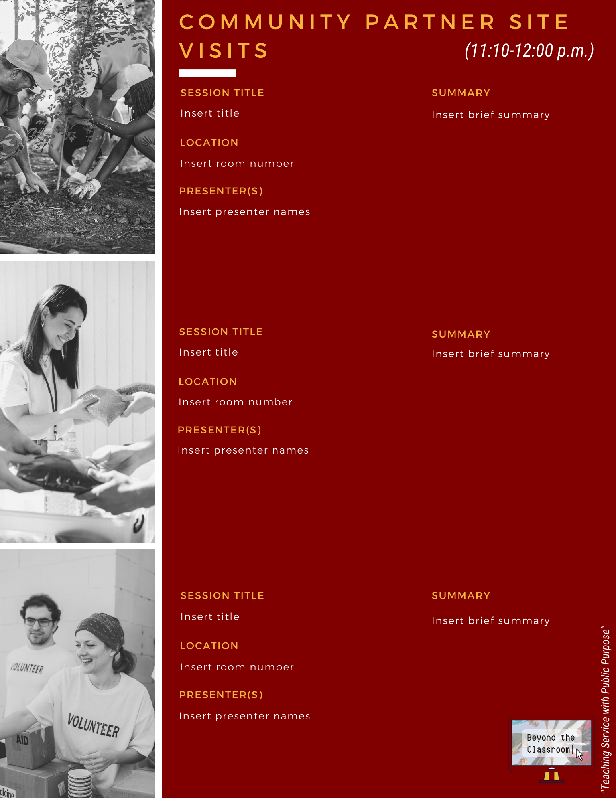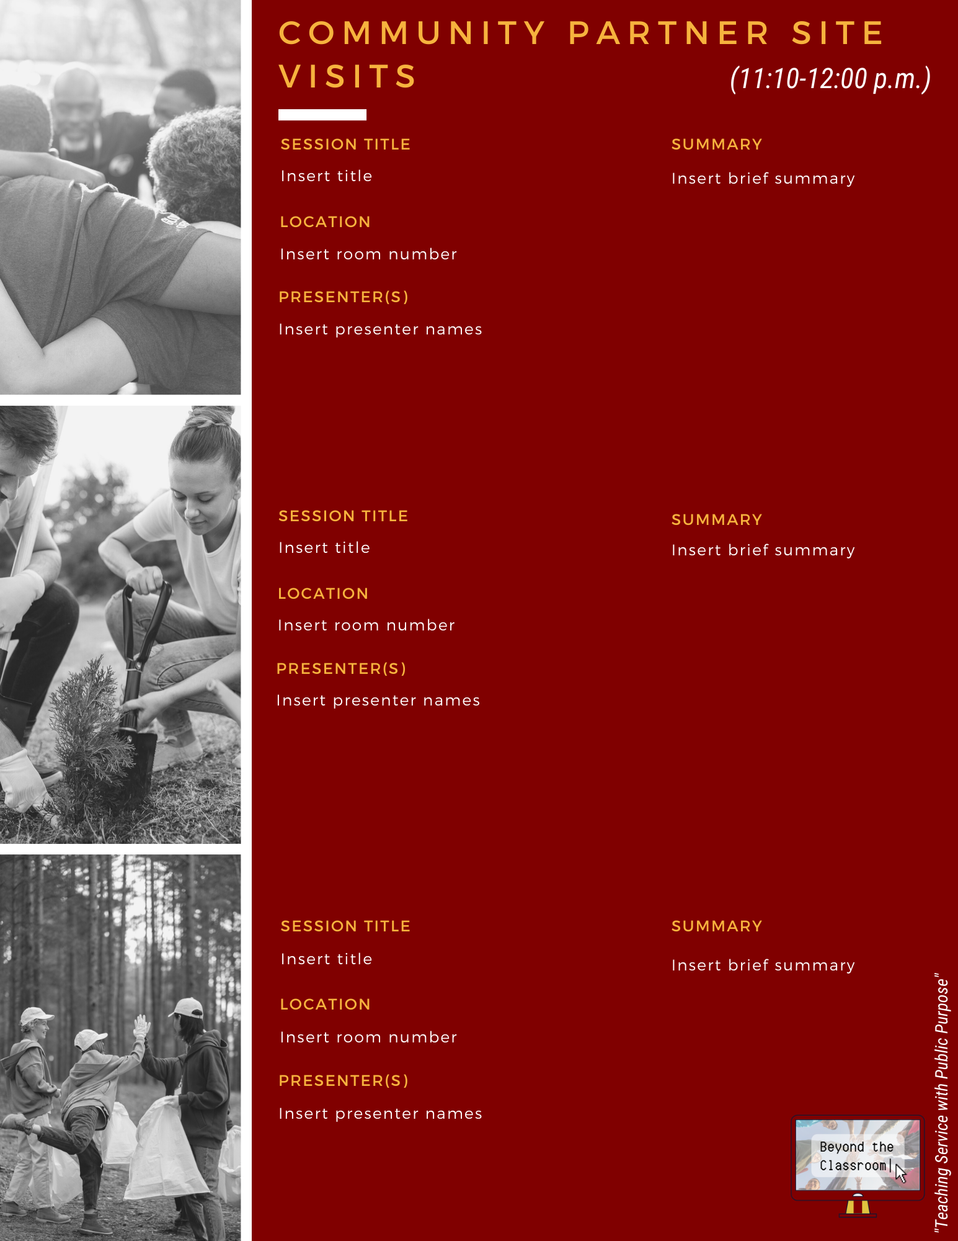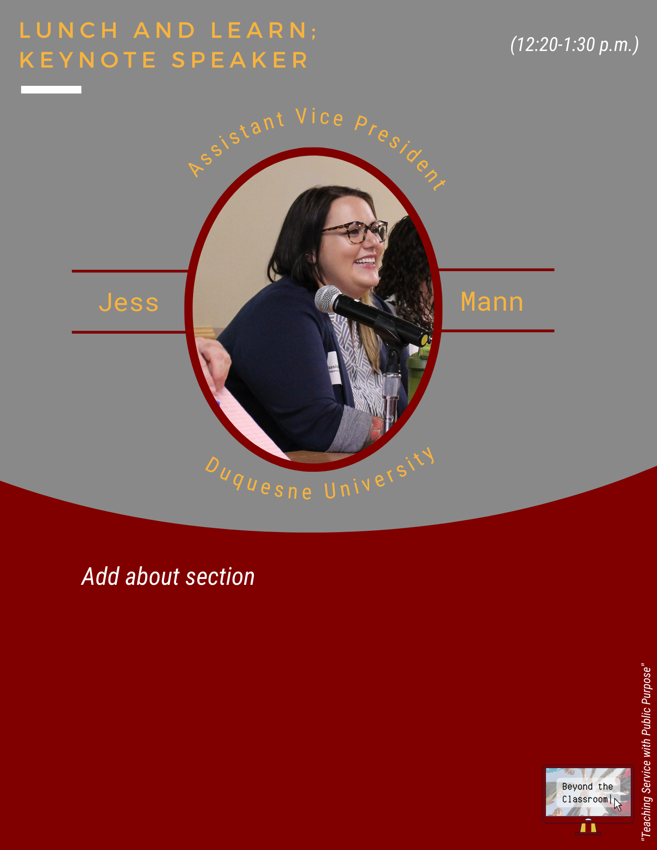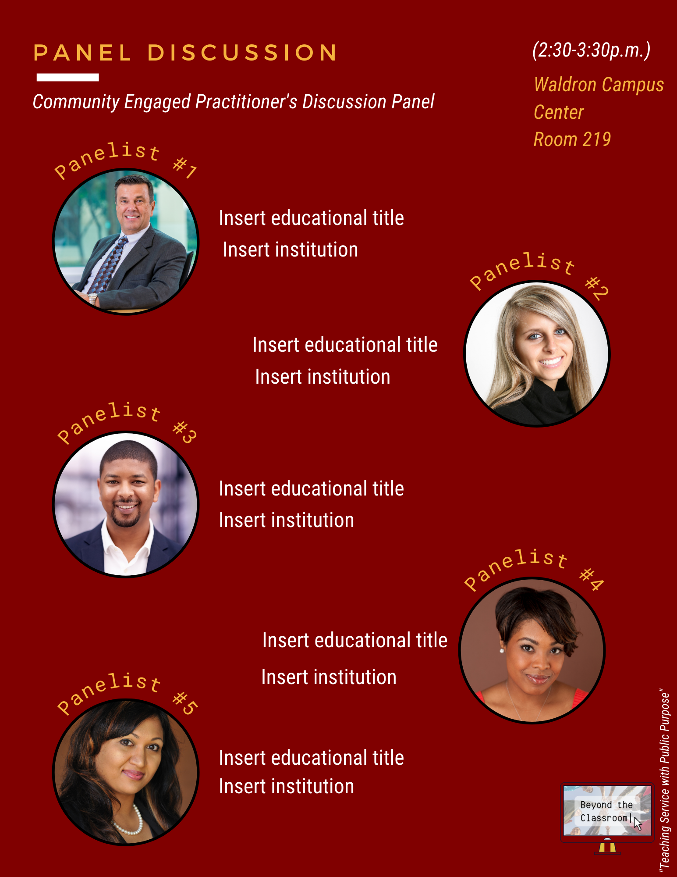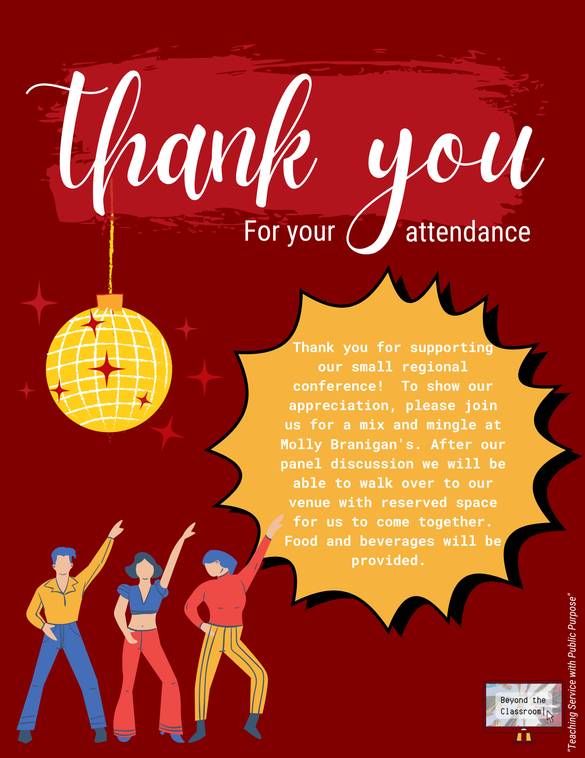

  - Sign-up Sweepstakes
To entice potential attendees to sign up early on, it is suggested a sweepstakes is commenced. The sweepstakes will involve attendees to be entered into potentially winning a $25 Amazon gift card. Two winners will be offered, to create a more tangible and reachable award, increasing the likeness of consumers participating. Attendees will be notified about this via email, as well as have it promoted on the Facebook and Eventzilla website. In order to be considered for a chance to win, attendees must sign-up for the conference by a certain date. Including this sense of urgency around a desirable reward will help to further influence potential consumers to participate. Having this early bird special also creates interest for the event early on.
The sweepstakes will run from March 2nd to April 2nd. The winners will be randomly selected and announced at the conference, where they will also receive their prize. These prizes are tangible in value and relevant enough to college faculty, staff, and even students to motivate their entry in the sweepstakes. After being exposed to ACE through these sweepstakes, potential consumers will become more aware of who ACE is, potentially influencing them to interact beyond the media they receive and attend the conference.

Post for social media:

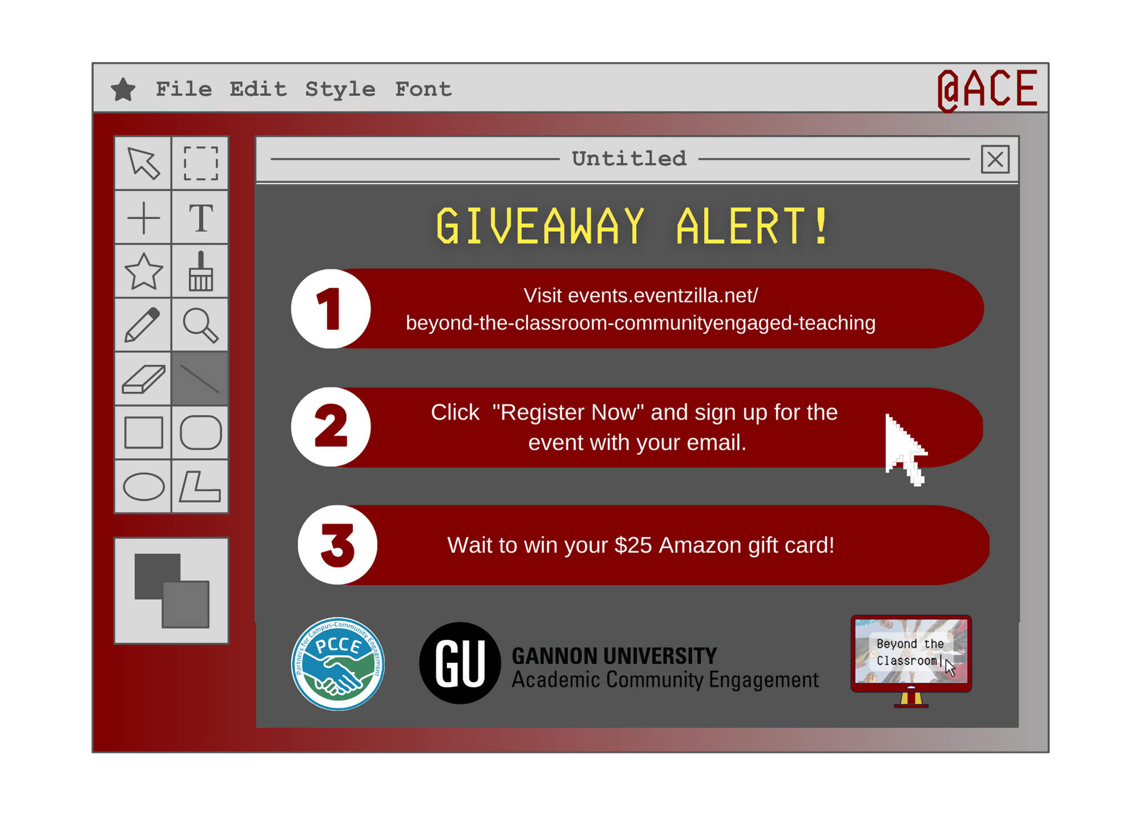

  - Stickers
Marketing for the “Beyond the classroom” conference will occur not just before the event, but during and after as well. This will be achieved through the use of custom stickers. The design of the stickers will be the event logo to stick with an IMC strategy. These free gifts will stay with them all year-long, reminding them of the enjoyable time at the conference. Stickers can be ordered from uprinting.com at a reasonable price of 150 stickers at 15 cents each for a total of $22.50 There are various ways in which the stickers can be administered, leaving that decision ultimately up to ACE. Some recommendations include giving them out at registration, laying them out on a table during breakfast, set on chairs during the welcome ceremony, or spread across tables at the celebratory mixer.
Using stickers with the logo also provides free advertising for ACE. Attendees could put the logo sticker in visible places such as their water bottle or laptop, leading for others that view it to spark conversations around it from intriguement. With the event name and website on it, even those that do no want to act on their curiosity can look into it themselves via the internet. Moreover, this can influence not only others to attend the conference, but for already established consumers to return again the following year, strengthening their brand loyalty.
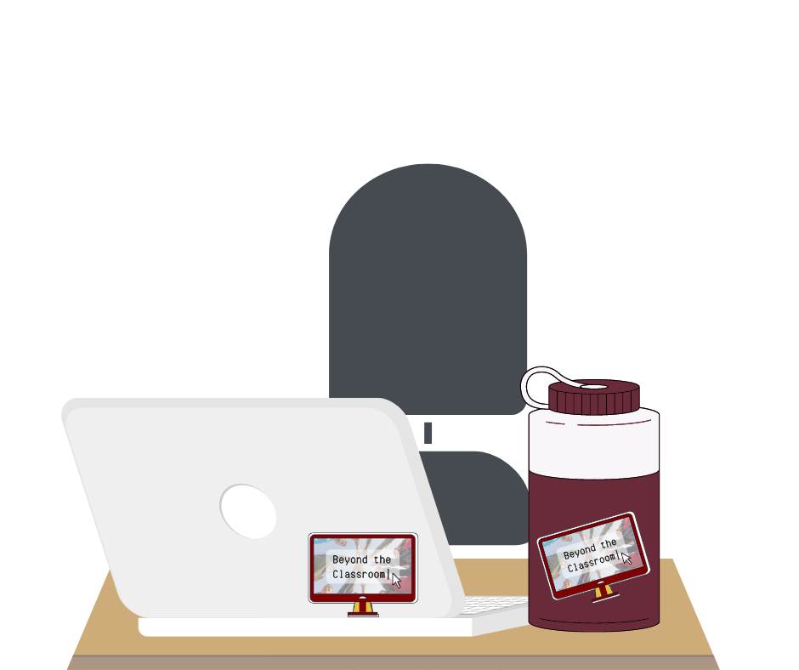

- Timetable
February 2023 - June 2023
*Specific dates are subject to change based on when certain information is released.

Month | Media Kit | Email | Social Media | Direct Mail | Out-of-  Home | Program | Sweepstakes | Stickers
February | 15th: Upload to  Eventzilla website. | 13th: Send email to identified groups. | M: Post #1  W: Post #2  F: Post #3 | 14th: Receive postage from the website. | 15th: Send to the print shop.  20th: Notify each office at every school beforehand via email.  25th: Review and send to institutions. |  | 21st: Email house list about it.
March |  | 6th: Send email to identified groups.  27th: Send email. | M: Post #1  W: Post #2  F: Post #3 |  |  |  | 1st: Advertise on social media  2nd: Sweepstakes begin.
April |  | 17th: Send email to identified groups. | M: Post #1  W: Post #2  F: Post #3 | 11th: Direct mail is sent. |  |  | 2nd: Sweepstakes ends. | 15th: Send to printer.
May |  | 8th: Send email to identified groups.  29th: send email. | M: Post #1  W: Post #2  F: Post #3 |  |  | 12th: Print out programs. | 24th: Input names into a drawing generator.  30th: Purchase gift cards.
June |  | 10th Send survey email. | 3rd: Thank you to attendees and photos of the event. |  | 5th: Send email to take posters down. |  | 2nd: Draw winner live at event during welcome. Winners receive prize. | 2nd: Place at designated spot at conference.

- Budget:
The Office of Academic and Community Engagement has capped their marketing budget at $350. I was able to come extremely close to this desired budget, only going $47.22 over. Funds have been divided among the categories of the types of proposed communication strategies and tactics. It is suggested that they employ an activity-based budget. This type of budget approach focuses on the key outcomes a business intends to achieve. It begins with the end in mind, then explores what must be done as an organization to achieve its primary goals. An activity-based budget defines the necessary resources and activity required to support identified objectives. Listed below are the activities as well as average costs to run those activities successfully:
Graphic design (for all communication pieces)
- Canva.com: 1 month free trial + 14.99/mo x 3 months = $44.97
Posters
- Uprinting.com: $0.29 x 500 posters = $143.55
Direct Mail
- Postcardmania.com: $0.05/postage x 227 schools + 12 postcards each = $136.20
Stickers
- Uprinting.com: $0.15/sticker x 150 stickers = $22.50
Sweepstakes
- $25 Amazon Gift Card x 2 = $50.00
TOTAL EXPENSES……………………………………………………. $397.22

- Conclusion
As a public relations professional, I am extremely dedicated to developing new, innovative, and compelling ideas to satisfy all needs that clients may have. After thorough analysis through primary secondary research, I believe that the established target audience of faculty, staff, and then students is the most effective to meet ACE’s objectives. Furthermore, the marketing plan that myself have developed will produce the greatest number of benefits and maximum impact for the organization. Furthermore, I believe in allocating revenue to areas in which results will be the most warranted for ACE and the “Beyond the classroom” conference, leading for myself to develop a plan to use the budget to its most strategic extent. Consequently, I have ensured that a plan has been developed that corresponds with an integrated traditional direct marketing and digital advertising campaign to ensure maximum communication impact is achieved.
I believe by choosing myself, Ash Keenan Public Relations, to represent ACE in their marketing needs, we will successfully achieve the set objectives as a team within the plan, bringing the organization the recognition it deserves for all it has to offer. One small idea can change an organization, so it is my hope that you consider the proposed strategies in this plan to implement. Thank you to ACE for their consideration in hiring myself to coordinate your marketing efforts. I look forward to working with you, as well as potentially seeing my work utilized in your marketing strategy to bring you the success that you desire.

- Sources:
- https://dpi.wi.gov/service-learning/why
- https://prlab.co/blog/what-is-a-pr-campaign-and-famous-examples/

- https://uk.indeed.com/career-advice/career-development/pr-campaign

- https://greenbuzzagency.com/marketing-psychographics-talking-about-my-generation/#:~:text=Baby%20Boomers,-Baby%20boomers%2C%20born&text=Psychographics%20tell%20us%20that%20the,of%20currency%20to%20make%20transactions.

- https://www.zippia.com/college-professor-jobs/demographics/
- https://greenbuzzagency.com/marketing-psychographics-talking-about-my-generation/#:~:text=Baby%20Boomers,-Baby%20boomers%2C%20born&text=Psychographics%20tell%20us%20that%20the,of%20currency%20to%20make%20transactions.

- https://www.zippia.com/college-professor-jobs/demographics/
- https://www.chronicle.com/article/what-are-the-demographics-of-noninstructional-staff-at-colleges?emailConfirmed=true&supportSignUp=true&supportForgotPassword=true&email=ashlynkeenan%40gmail.com&success=true&code=success&bc_nonce=ma72dv9n5 nexi83twfjhi&cid=gen_sign_in
- https://www.aecf.org/blog/what-are-the-core-characteristics-of-generation-z
(https://nces.ed.gov/programs/coe/indicator/cpb/college-enrollment-rate#:~:text=The%20college%20enrollment%20rate%20in,Alaska%20Native%20(22%20percent).

