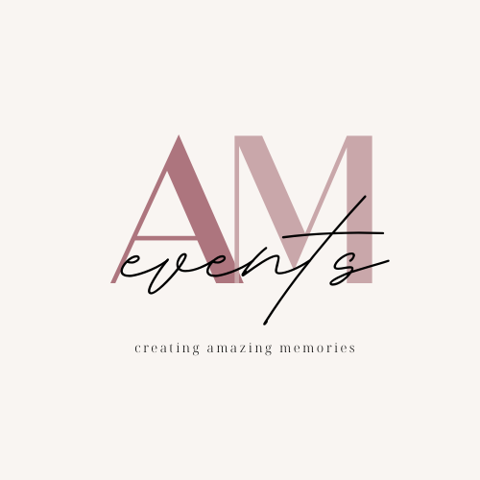

Local Event Plan

COMM 327 Event Planning

Gannon University

October 5, 2021

Submitted by: Ms. Ashlyn Keenan and Ms. Megan McCartney

Submitted to: Ms. Anne O’Neill

***Table of Contents***

Number: Section: Page

1. **Introduction 2**
2. **SWOT Analysis 3**
3. **Target Market/Audience 5**
4. **Key Message/Event Scope 6**
5. **Goals and Objectives 8**
6. **Promotional Strategies 9**
7. **Event Activities 10**
8. **Communication Assessment 13**
9. **Timetable 14**
10. **Budget 15**
11. **Summary/Conclusion 16**
12. ***Introduction***

This plan is produced by A & M Events for the Athletics Department at Gannon University, Erie, PA. Our client contact is Kelly Boomer, the Budget and Special Projects Manager for Gannon Athletics, and can be reached at [bommer001@gannon.edu](mailto:boomer001@gannon.edu). The organization is planning to host a pregame party before the men’s basketball home opener game. This marketing plan will outline identified goals and objectives that Gannon Athletics will aim to achieve for the event.

A & M events is the latest and upcoming event coordinating business in the Erie County area. A & M strives to accomplish its mission to produce events that create amazing memories for its clients.

1. ***SWOT Analysis***

To try and decide more about this event we had to figure out what are the strengths, weaknesses, opportunities, and threats for a Gannon event. Doing a SWOT on Gannon will help us realize what is lacking and to help us define the best advantages we have to help us make a successful event.

1. Strengths
   1. Gannon has a lot of potential sponsors so do not need to worry about a budget.
   2. Gannon resources such as athletics and marketing departments are free to use.
   3. Strong on-campus following for men’s basketball.
2. Weaknesses
   1. Student apathy towards the event.
   2. Low school spirit around campus.
3. Opportunities
   1. Increase the number of fans to attend the game after the tailgate.
   2. Spread school spirit around campus.
   3. People are eager for in-person events after COVID, so there is a high potential for attendance.
   4. Set standards for future Gannon tailgates.
4. Threats
   1. No one showing up to the tailgate.
   2. The game being canceled.
   3. COVID postpones the game or prevents people from attending.
   4. Other events potentially may be going on that day on campus.
   5. The date is close to finals so students might have other obligations.
   6. Not being able to secure the room for activities.
5. ***Target Audience***

After conducting a primary research survey, a primary audience and two secondary target audiences were established in order to determine how to promote and market this event at Gannon University.

The primary audience for the tailgate is undergraduate students at Gannon. Based on the data collected from the survey, undergraduate students occupy the largest portion of the population at Gannon. In addition, the data also expressed that undergrad students are more likely to attend Gannon events in comparison to other markets. Some psychographics are students who are athletes, students who are fans of basketball, and students who are friends of the athletes.

The secondary audiences for this event are current graduate students at Gannon University and Gannon faculty and staff. The event is open to Gannon only and not the public, hence why the audiences are all internally situated at Gannon.

1. ***Key Message/Event Scope***

The “sleep when you win” pregame party will be an informal event that will be held on Monday, November 15th at 5:30 p.m. The theme of the event is a pajama theme that corresponds with the name of the event and was chosen due to the time of year. Since this will be held sometime in November, the weather will be cold and pajamas will keep attendees warm, increasing the likelihood of participation. Decor colors for this event are limited to maroon and gold to match Gannon’s colors.

The event will be held inside of the Waldron Campus Center. The event will start an hour and thirty minutes before the game starts. Activities will occur on the second floor of Waldron in room 219. Guests will have the option to participate in various yard games and activities, as well as snack on food and beverages. After the pregame party, students are encouraged to head downstairs to the gym to watch the game.

Attendees will be expected to download the Corq app to check-in digitally once there but aren’t required to. Purposes of this event include generating school spirit about the game on campus, influencing attendees of the tailgate to stay to cheer on the players in the home opener, and raise awareness for the Gannon University Athletics department.

Graphics used to advertise this event will be the same across all media channels. The proposed graphic is the Gannon University colors in order to stay on brand with the organization’s image. Additionally, basketball visuals are used in the graphics to communicate what the event is attempting to promote. Additionally, space graphics such as a moon and stars are also used on the poster to communicate and stay on brand with the established theme. The proposed graphic to use for the event is as follows:

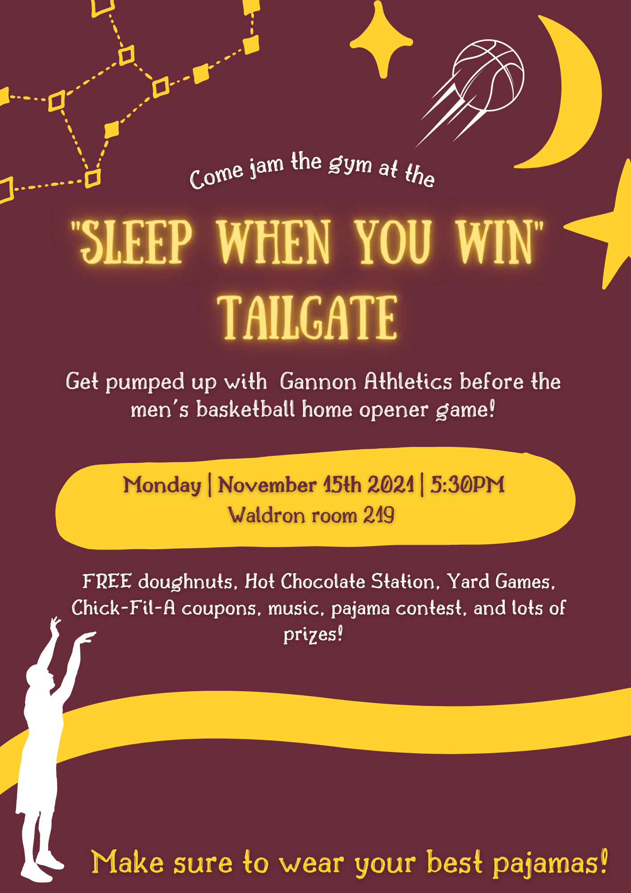

1. ***Goals and Objectives***

Below are the objectives of the event and goals to be met during the duration and conclusion of the event:

* To have a minimum of 50 individuals in the Gannon community attend the day of the event.
* To attract 25 people to enter the sweepstakes at the tailgate.
* To have 35% of attendees participate in the pajama theme the day of the event.
* To have a minimum of 3 media in which promotional messages are displayed between October - November.
* To influence 50% of tailgate attendees to attend the game after the tailgate.

1. ***Promotional Strategies***

**In advance of the event:**

* Digital graphic for Gannon’s social media
* Poster for on-campus kiosks
* WERG promotional announcement
* Gannon Knight Ad
* Posters and Flyers for tables and boards around campus
* Creation of Logo for “sleep when you win”
* Identify and solidify sponsors and what they will be providing.

**During the event:**

* Update Gannon and the Athletics department’s social media during the event.
* Asks attendees to use the hashtag #sleepwhenyouwin posting on social media.

**After the event:**

* Send a thank you note to sponsors.
* Send messages to congratulate the winner of the sweepstakes and costume contest.

1. ***Event Activities***

All activities that will happen at the tailgate will be provided by Gannon Athletics and Kelly Bommer. Prizes and Giveaways will be donated by Kelly Bommer and SGA. Majority of the activities will go with the “sleep when you win” pajama theme. Various clubs and teams will volunteer to sit at the tables to sign participants in and gain their volunteer hours.

1. Snap a picture with Knight cardboard cutout:
   1. We will be using the cut-out Gannon frame and the cardboard statue of Victor E. Knight so students and faculty can take pictures to post on their social media. The frame will be provided by Gannon along with other cut outs such as hats and glasses.
2. Cornhole:
   1. On the day of the event cornhole boards will be provided by Gannon and set up for attendees to play in teams of two or four. This station will not be monitored by someone, as attendees will be trusted to participate themselves without supervision.
3. Best Costume Contest:
   1. A panel of faculty members will be created to be the judges for the contest. These judges will determine which pajamas were their favorite for each category, and the winner will be announced at the conclusion of the event. There can be multiple categories such as: best gannon pajamas, best couples, etc. A Gannon swag, provided by Kelly Bommer, will be given to the winners of the contests. Winners of each category will receive some form of Gannon merchandise along with a gift card provided by the Gannon Athletics Department.
4. Sweepstakes to win some kind of prize:
   1. There will be tables with prizes and Gannon merchandise for students to attempt to win by entering their name and Gannon email.
5. Yard games:
   1. Yard games will be provided by Kelly Bommer such as kam jam, big checkers, large jenga, etc.
6. Music:
   1. The Gannon student radio station, WERG, will be broadcasting live from the event with music. The station will be providing the music at no cost, as well as provide a method to advertise the event to the target audience.
7. Pillow Toss/Teddy Bear Toss:
   1. There will be a table set up for people to enter and the contest is to see who can throw the pillow the furthest, or the teddy bear through a certain target. Could have two or more categories such as: girls, boys, athlete (girl or boy), nonathlete (girl or boy). Pillows will be purchased and provided by the Gannon Athletics Department.
8. Pillow Case Race:
   1. A table will be set up for people to enter and the winner(s) will receive a prize.
   2. Purchase pillowcases or Gannon will provide
9. Hot Chocolate Station:
   1. Attendees will be able to grab a hot chocolate at a hot chocolate bar. Hot chocolate will be served out of a crockpot, with a volunteer serving it in order to follow COVID guidelines. Individual disposable cups will be used to also ensure the health and safety of all those involved with the event. Attendees will have the option to top their hot chocolate with whipped cream, sprinkles, or peppermints.
10. ***Communication Assessment***

A & M Events will assess the promotional strategies used to determine if they were effective in achieving the identified objectives after the duration of the event.

Through the use of the Corq app, the number of attendees will be able to be tracked and analyzed to see if the goal number of attendees were met.

1. ***Timetable***

***Timeframe: September 2021 - November 2021***

September 2021:

* Meet with client to go over logistics of the event.
* Begin to reach out to sponsors to provide food, beverages, and supplies for tailgate.

October 2021:

* Get together materials needed for the event.
* Begin to start promoting the event.
  + Design poster/social media graphic
  + Send poster to the Gannon Press to be printed
  + Hang up posters around campus
  + Purchase ad space in the Gannon Knight
  + Send posters to the marketing department to upload on kiosks
  + Reach out to WERG to secure their services

November 2021:

* Finalize all elements for the pregame party
* Set up activities and decorations the day of the event

1. ***Budget***

A budget report is not necessary for this event as all elements will be paid for through sponsorships. One of the sponsors for the event is Chick-fil-a, who will donate breakfast cards, Mighty Fine Another sponsor will be the Student Government Association, or SGA, who will be in charge of providing free Gannon merchandise.

1. ***Conclusion***

The “sleep when you win” pregame party will take place at Gannon University’s men’s home opener basketball game in November of 2021. This event sponsored by Gannon athletics will occur on Monday November 15th, with a start time of 5:30 p.m. The overall goal of this event is to encourage more attendance at the men’s basketball game, as well as increase school spirit around campus. Our client has hopes to see results and collect research that can be utilized to plan more effective events in the future.